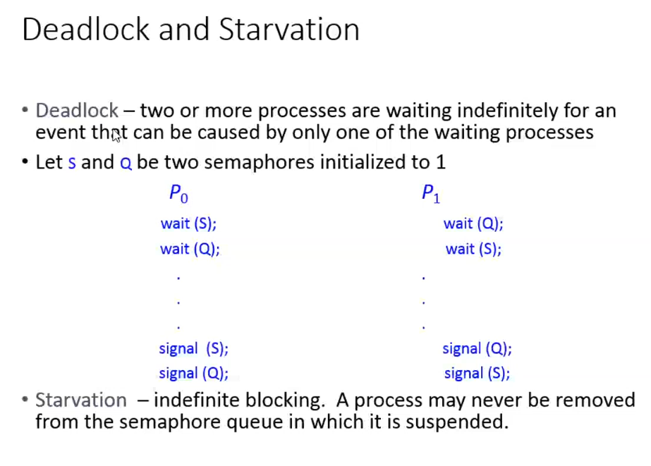

When P0 (or) P1 executing separately wait(S) and wait(Q) is done successfully and P0 enters into the critical section.

**When P1 can never enter??**  
After P0’s wait(S) and wait(Q) S and Q 🡪 0. So P1 cannot enter into the critical section.

**When P0 can never enter??**  
After P1’s wait(S) and wait(Q) S and Q 🡪 0. So P0 cannot enter into the critical section.

**When both P0 and P1 cannot able to enter into the critical section????**  
P0 executing wait(S) S 🡪 0  
P1 executing wait(Q) Q 🡪 0  
Now both the semaphore variables are 0, From now when P0 and P1 executing any wait() fully goes and stuck upto into the infinite while loop. So after this condition, both the process P0 and P1 will not proceed further. (Dead lock condition is achieved)

**Readers and writers problem**

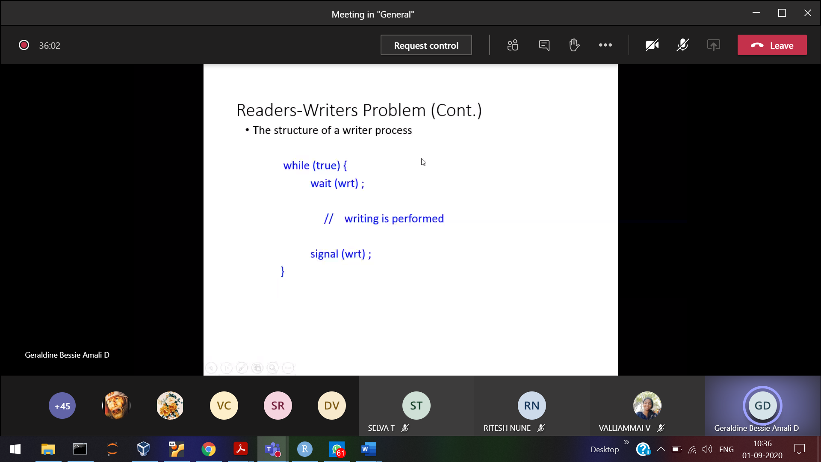

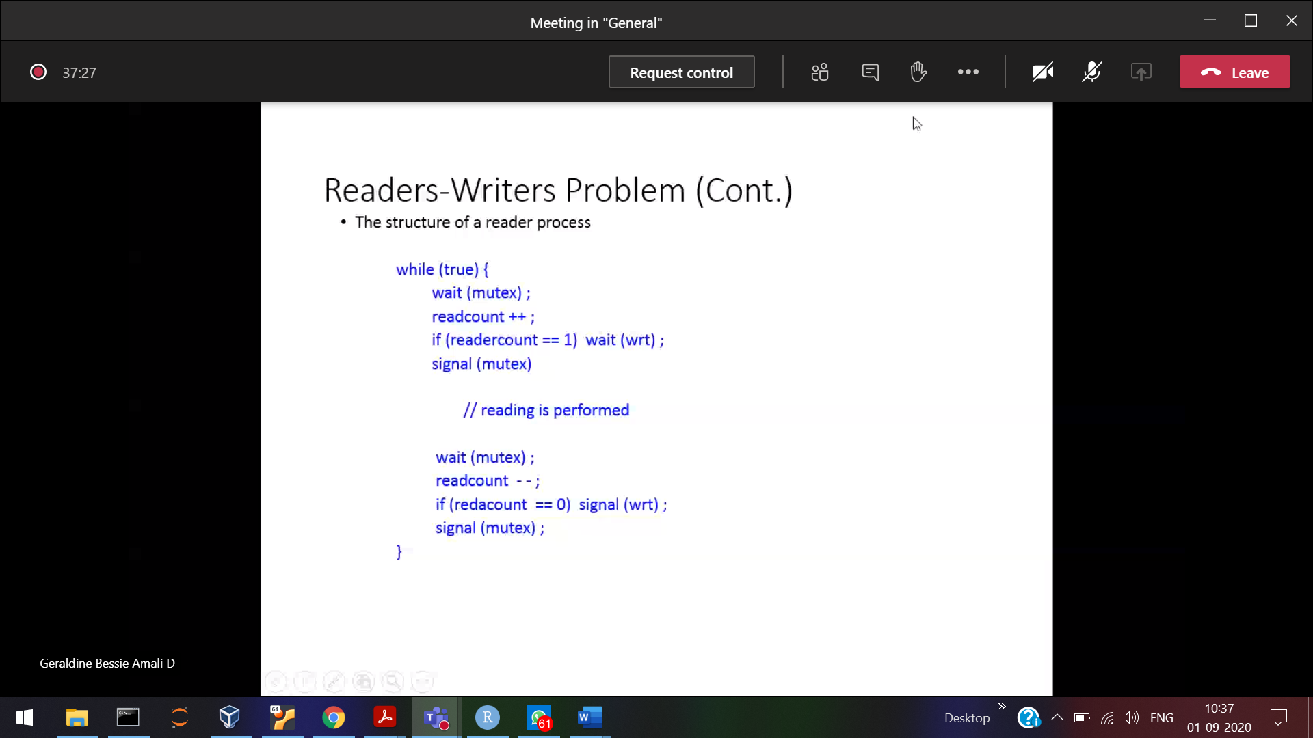

Practice for reader and writer simultaneously

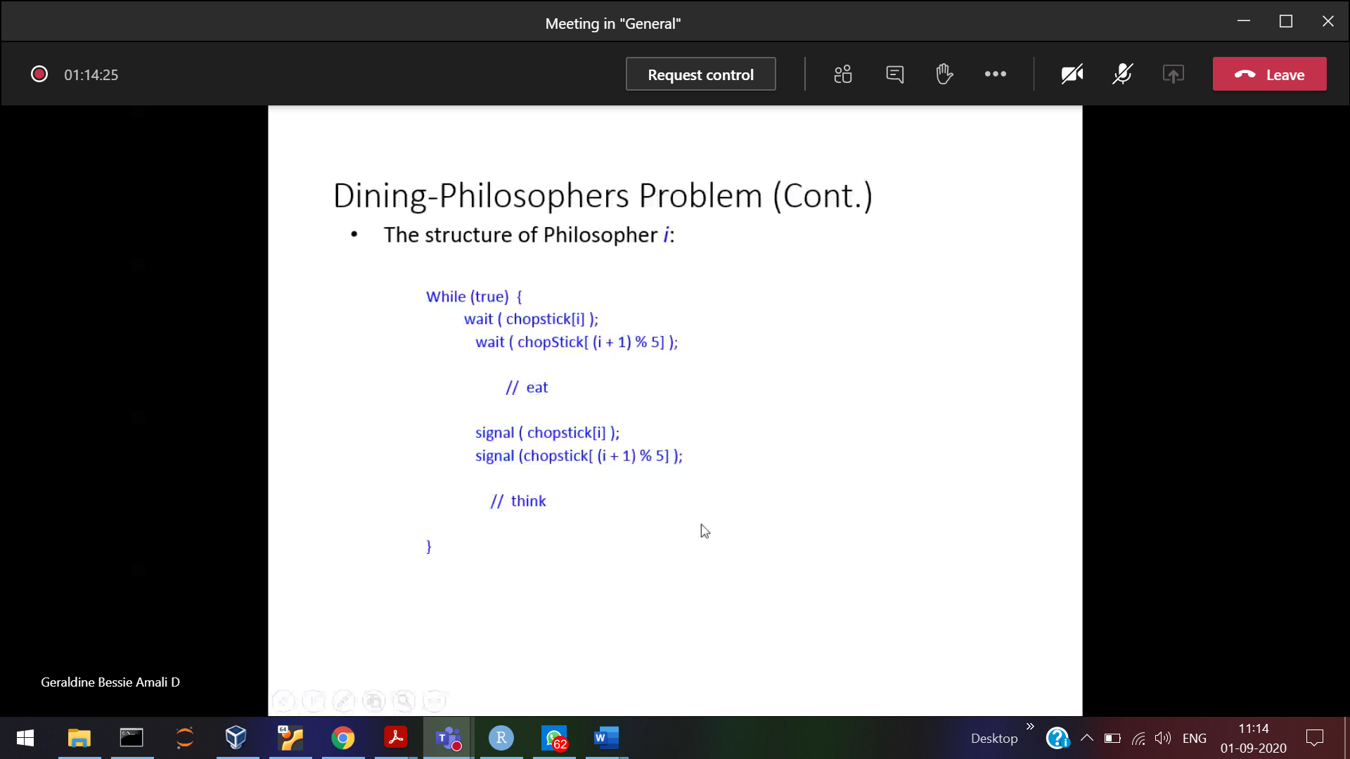

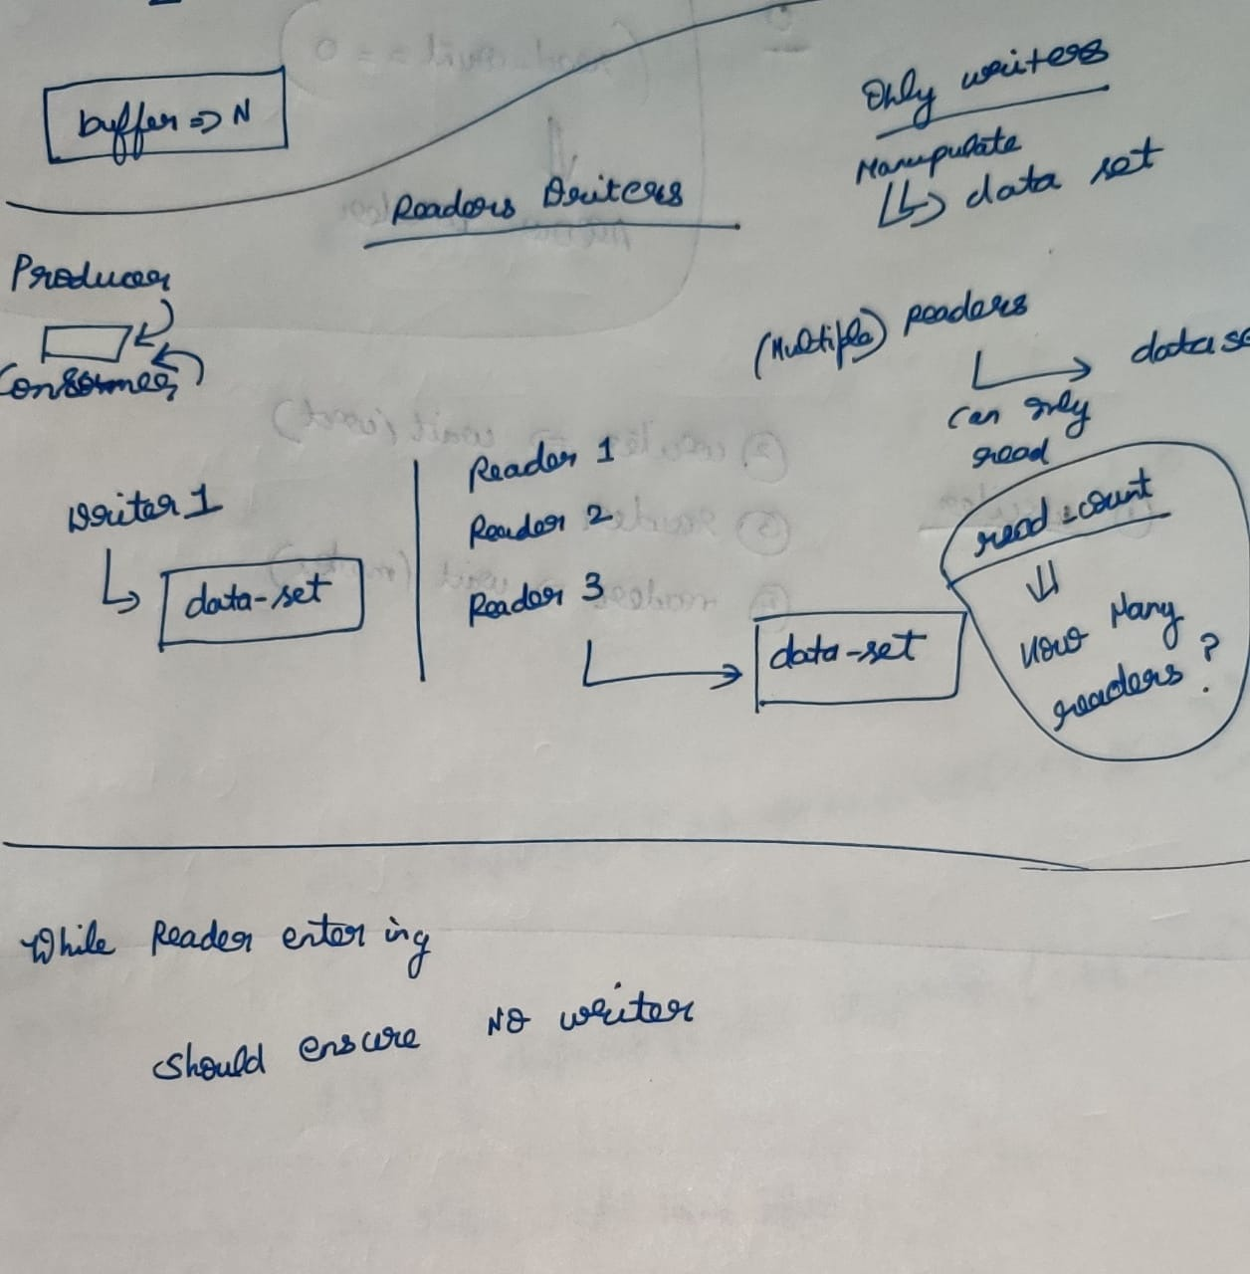

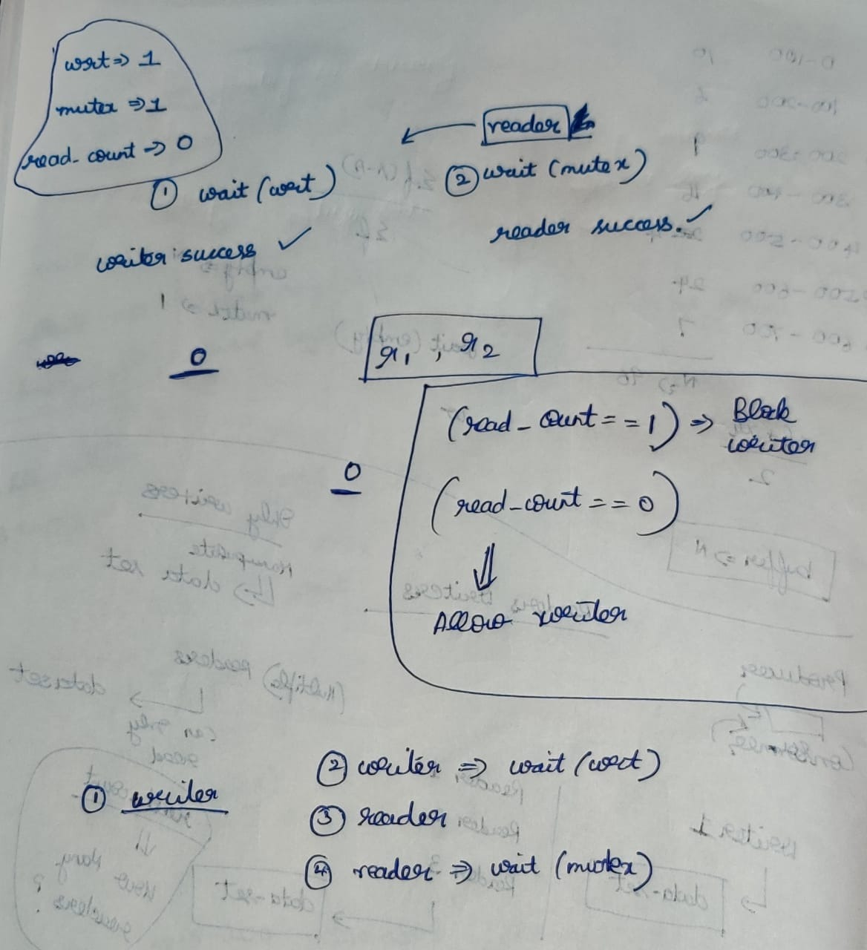

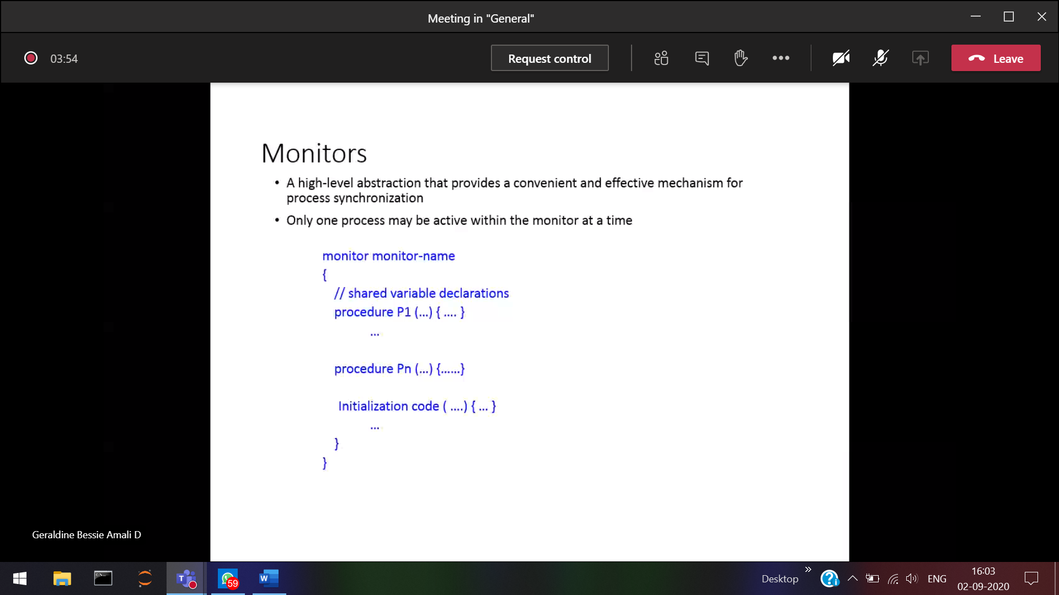

Abstract data-type 🡪 Similar to classes and structures

Shared variable 🡪 like buffer in producer and consumer problem + procedures which operate on the shared variable. Also ensures only one process at a particular time can access the monitor. [ All are encapsulated]

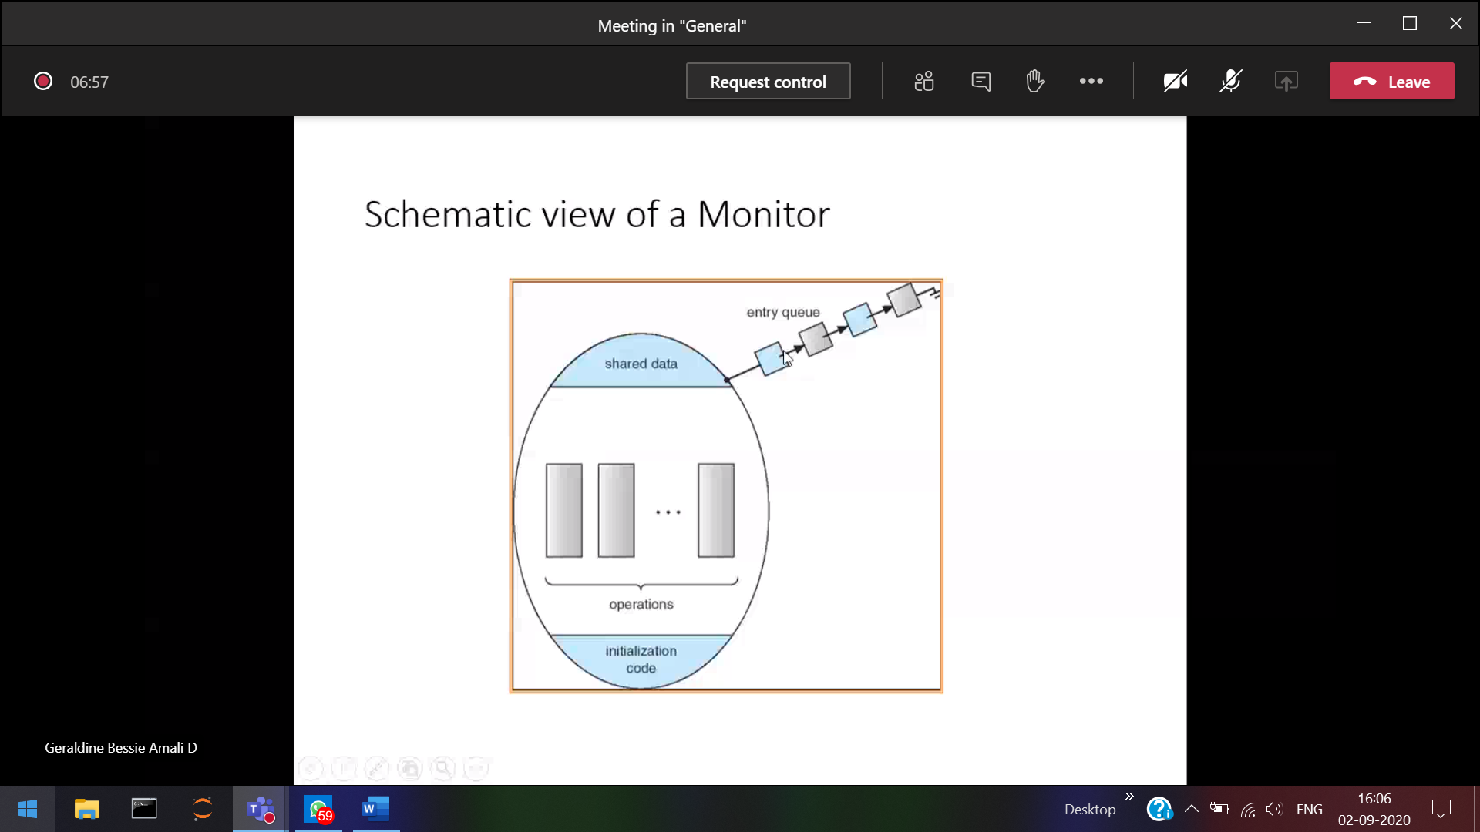

No more than 1 process can come in the Monitor (Implicitly Monitor will take care of it) and provide mutual exclusion

P1 comes in and hold the lock, So all the process should wait in the queue, Once after P2 releases the clock. Then only P2 can enter.

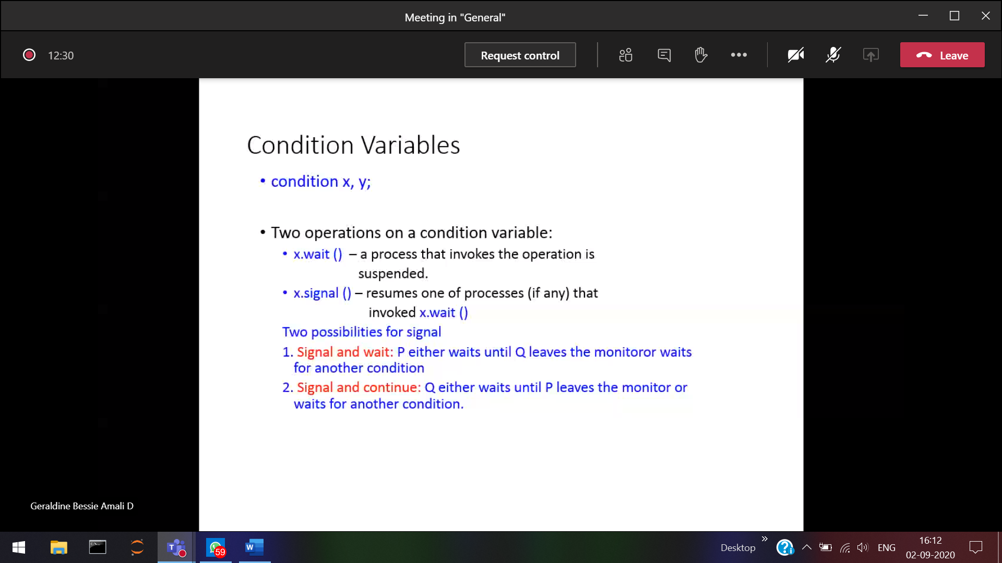

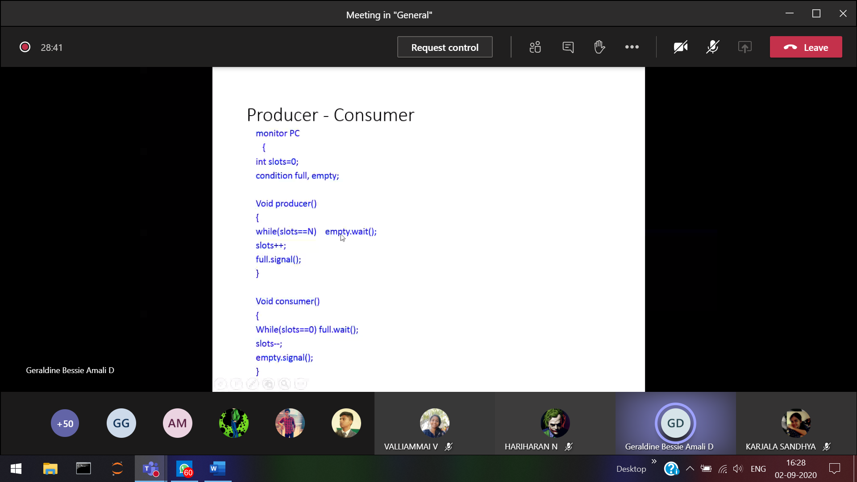

If no consumer waiting, producer will produce and go out

WHEN PHILopher wants to eat

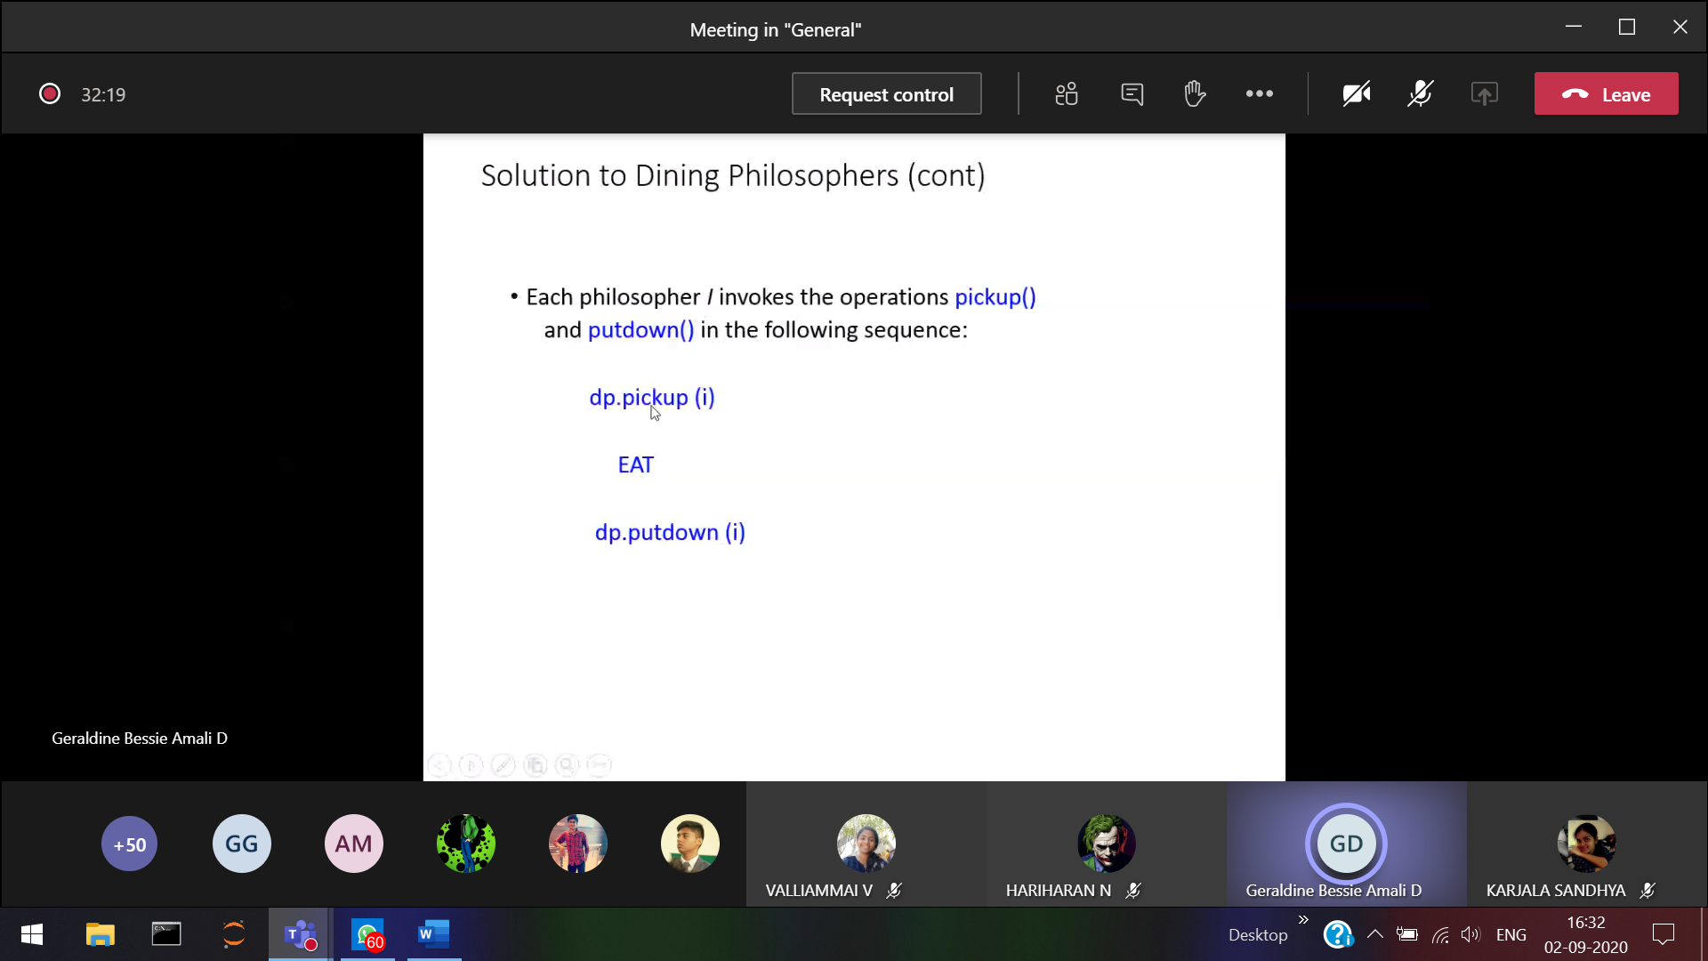

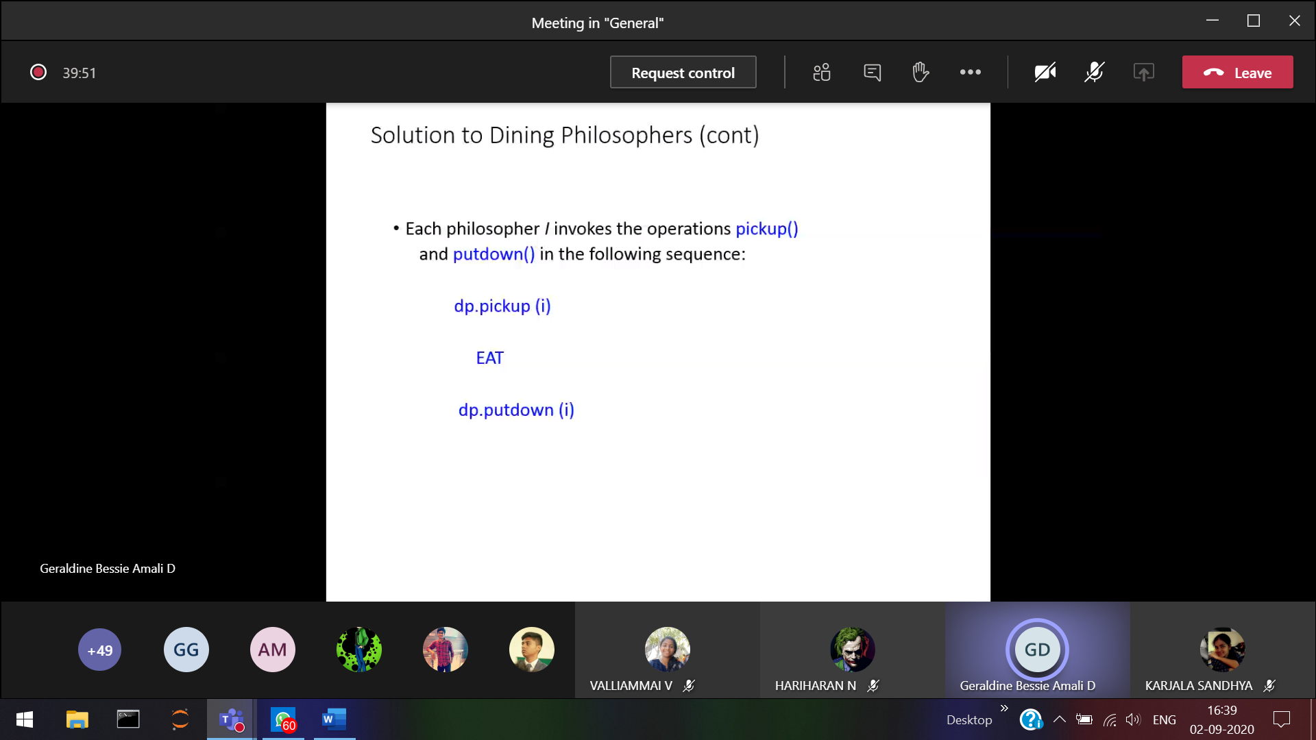

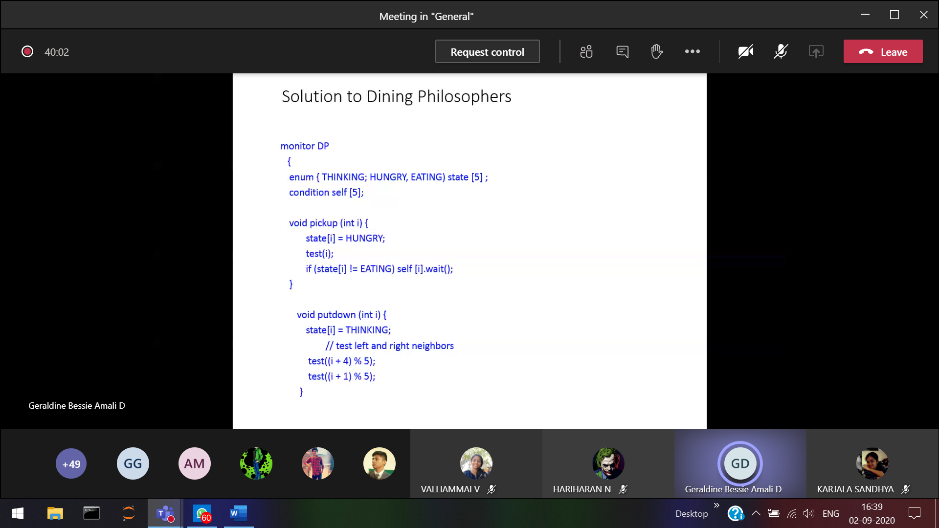

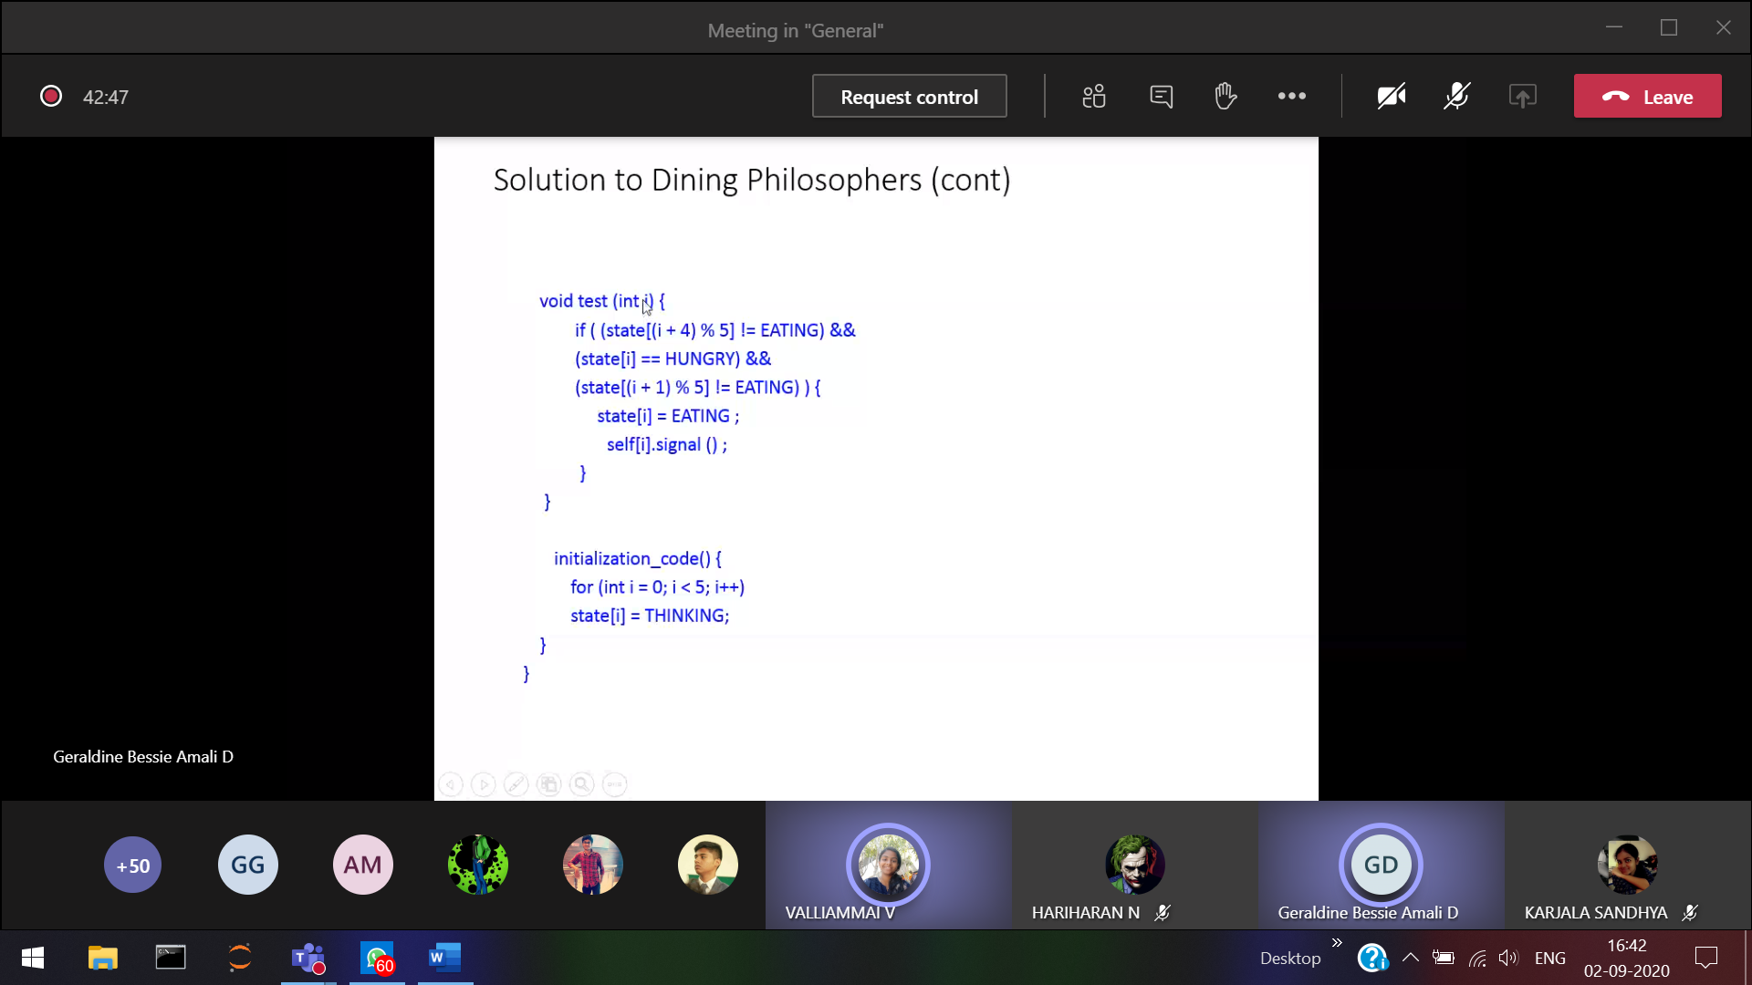

No chance for starvation.

**Dead lock condition:**   
When blocked processes hold on some resource and they wait for other resources which is being held by other blocked processes.

Eg: Simple scenario (b

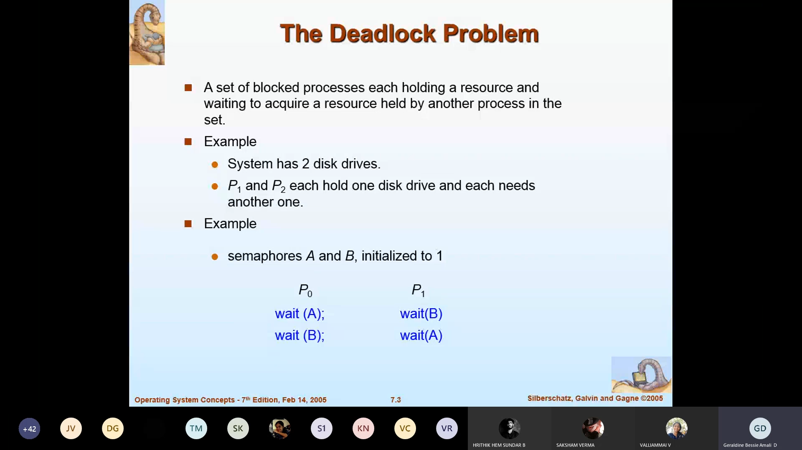

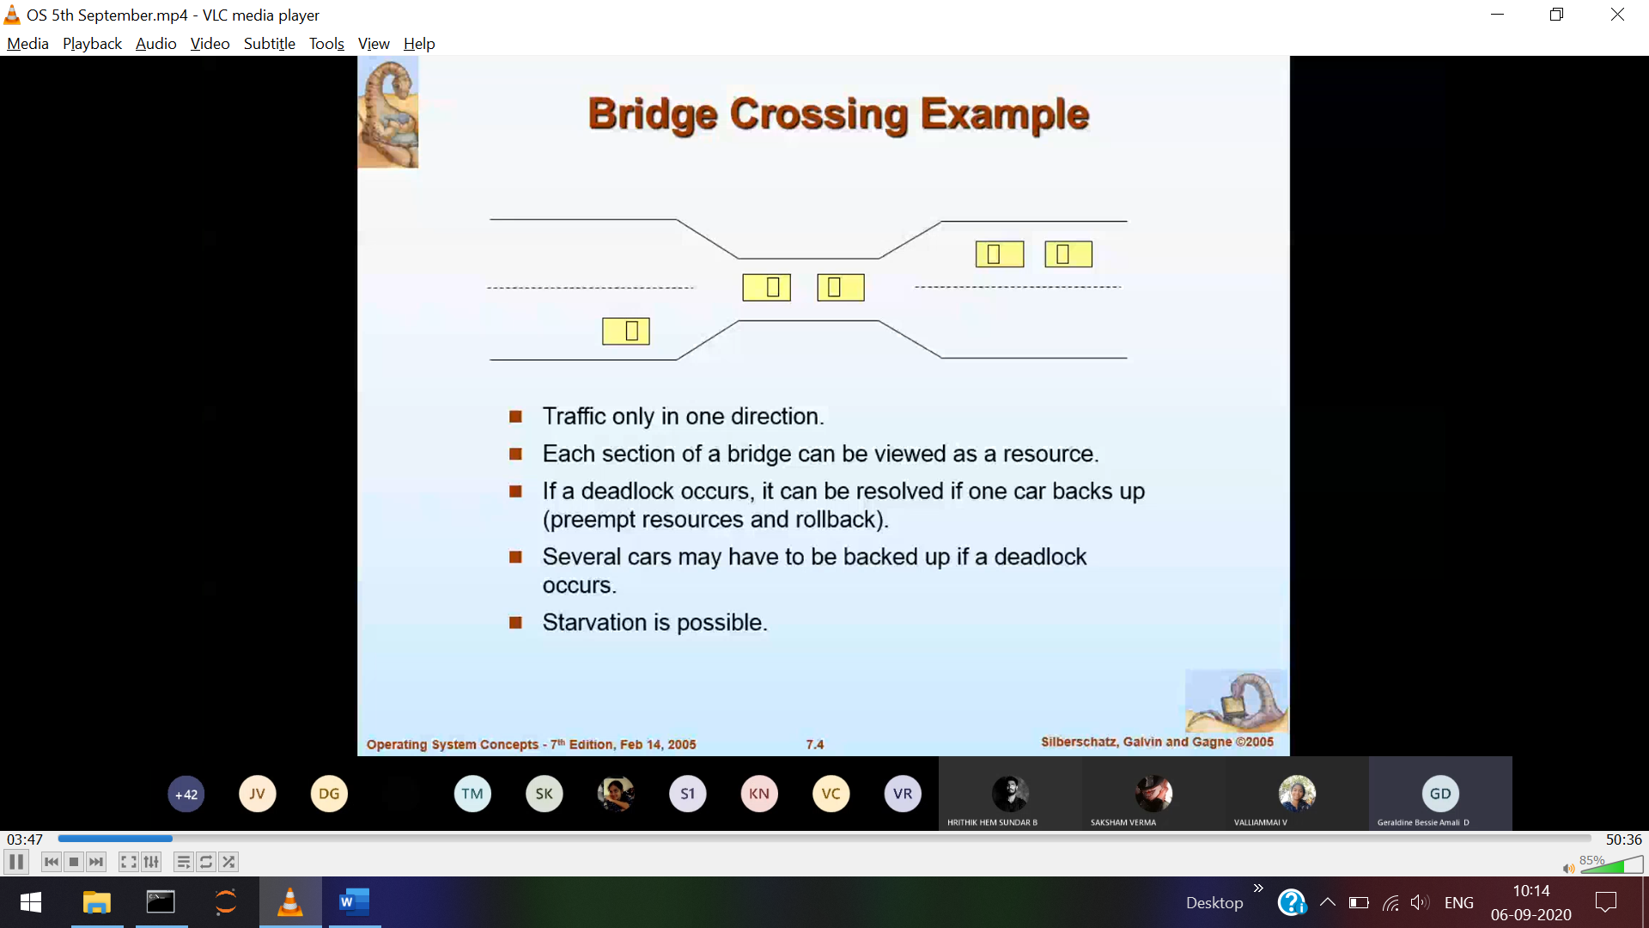

Dead lock condition in crossing the bridge.

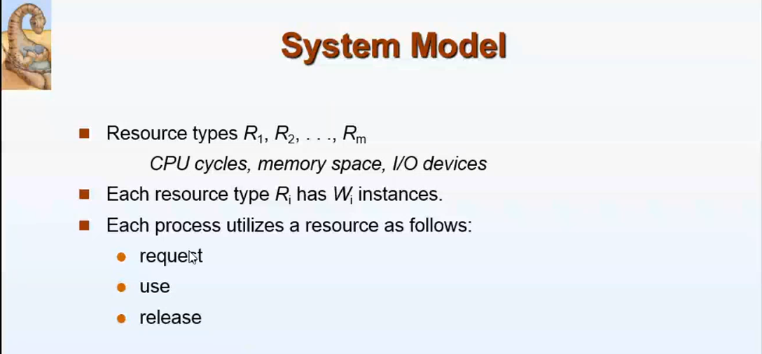

There are m resources in our PC.  
Every resources can be 1/every resource can have many instances.   
Eg: Quad core, octa core processes.

Every process should follow these three rules to use the resources.



Request use release



Problem start from here, the system holds in dead lock when these 4 conditions hold simultaneously.

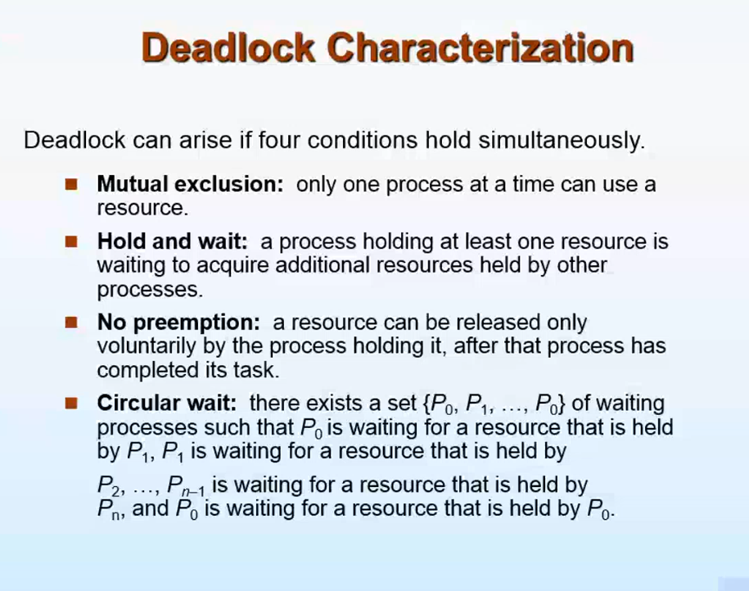

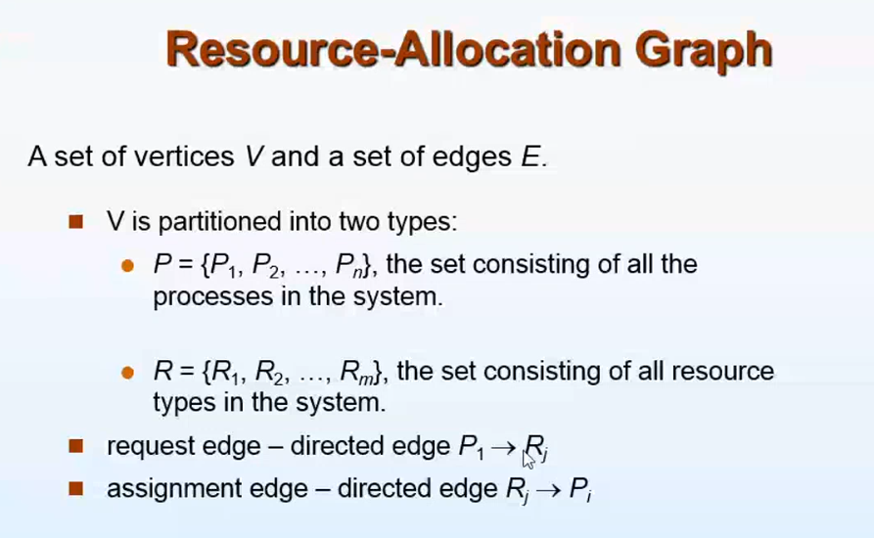

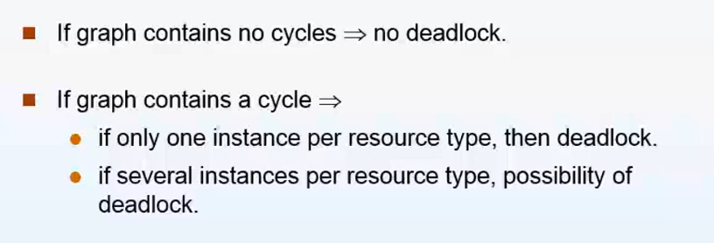

Out of all process, first see whose needs can be satisfied with the available resource  
P1,P2,P3,P4  
P1(first process) 🡪 available resources   
P2 🡪 P1(holding) + available resources  
P3 🡪 P1(holding) + P2(holding) + available resources

These ordering can differ

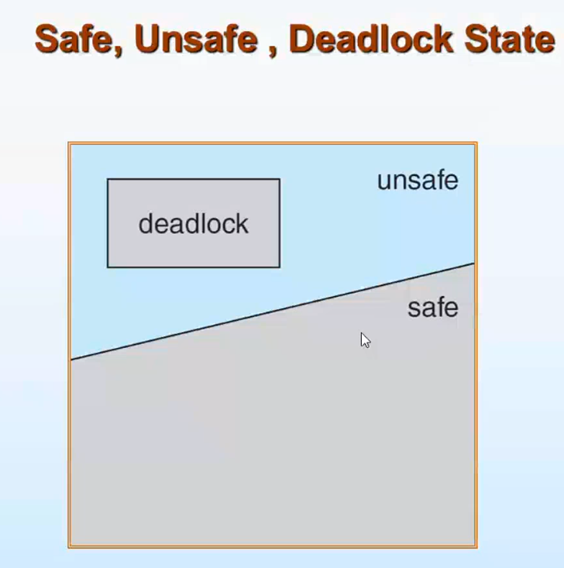

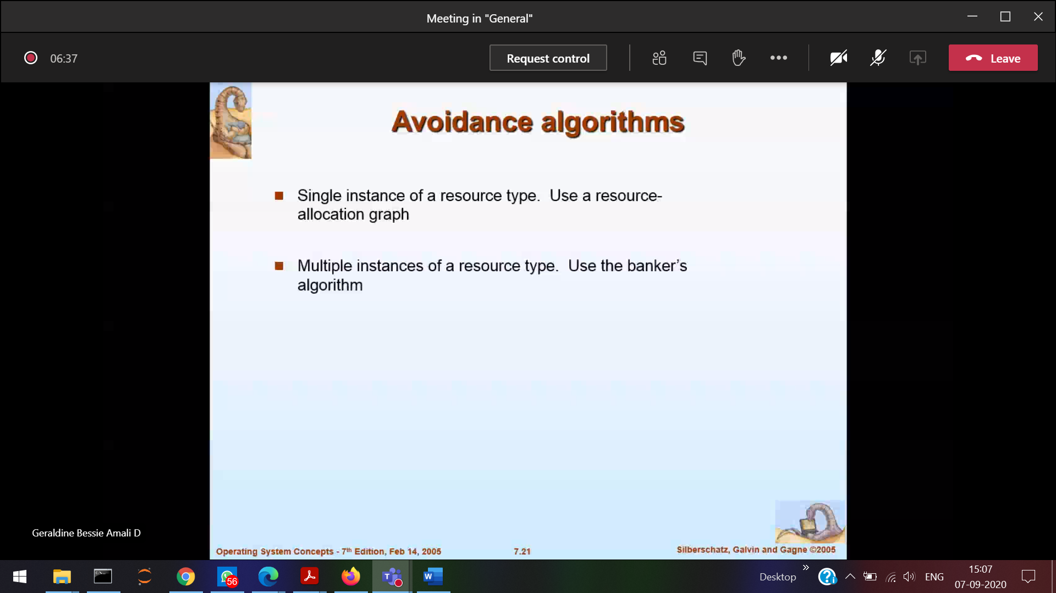

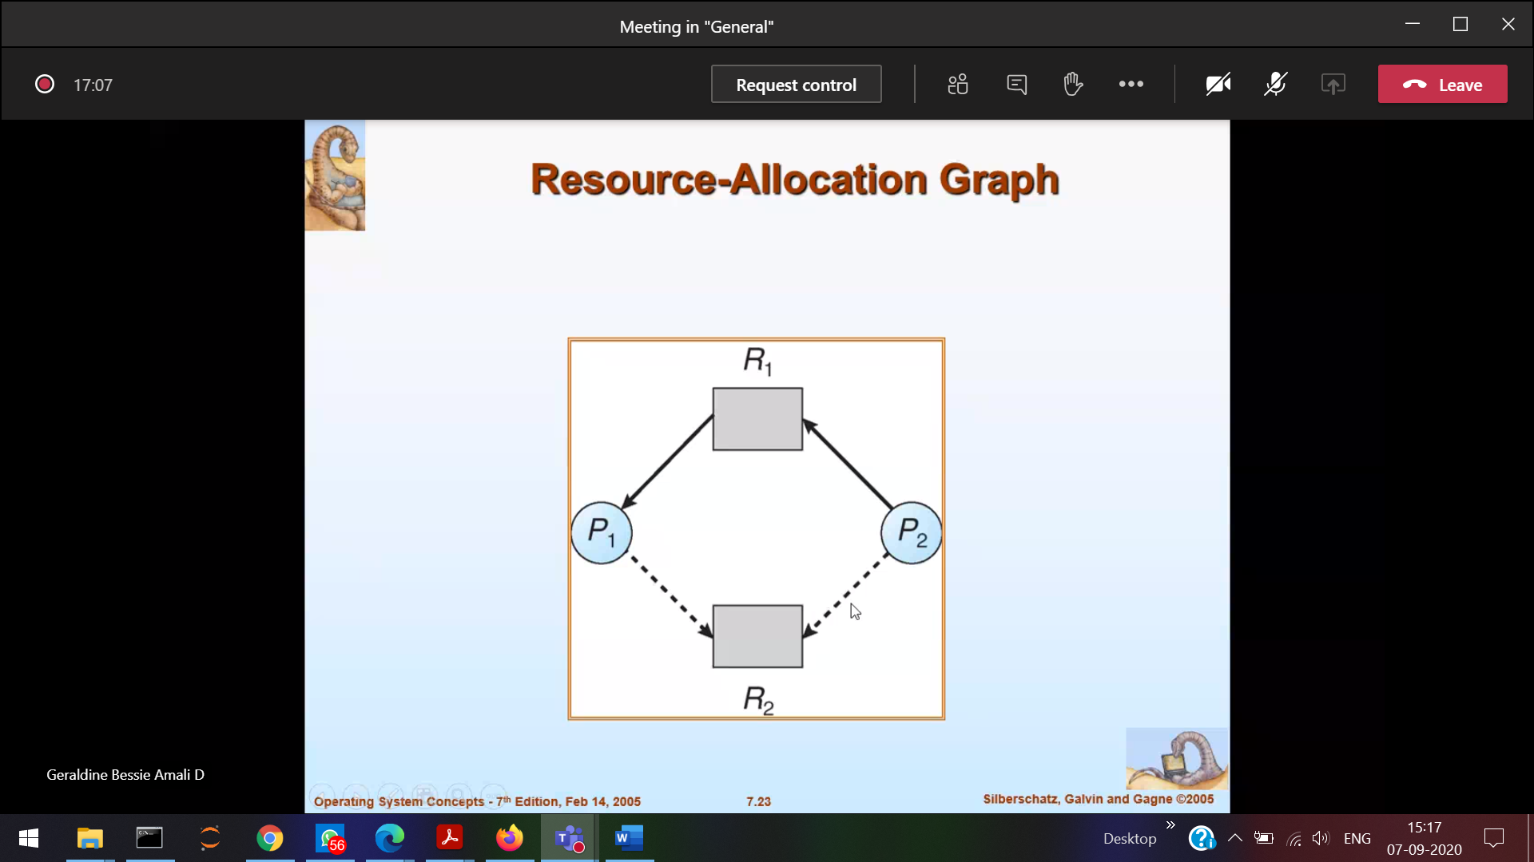

After some time P1 and P2 requires R2

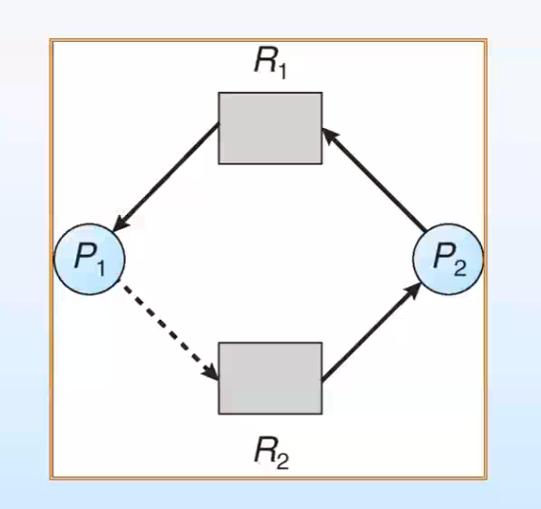

Dead lock(circle) [When R2 is allocated for P2]

Even though R2 available it will not grant (Check if deadlock happens)

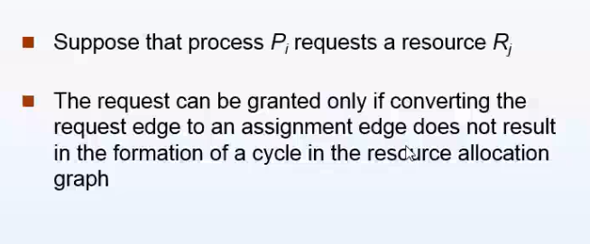

­­

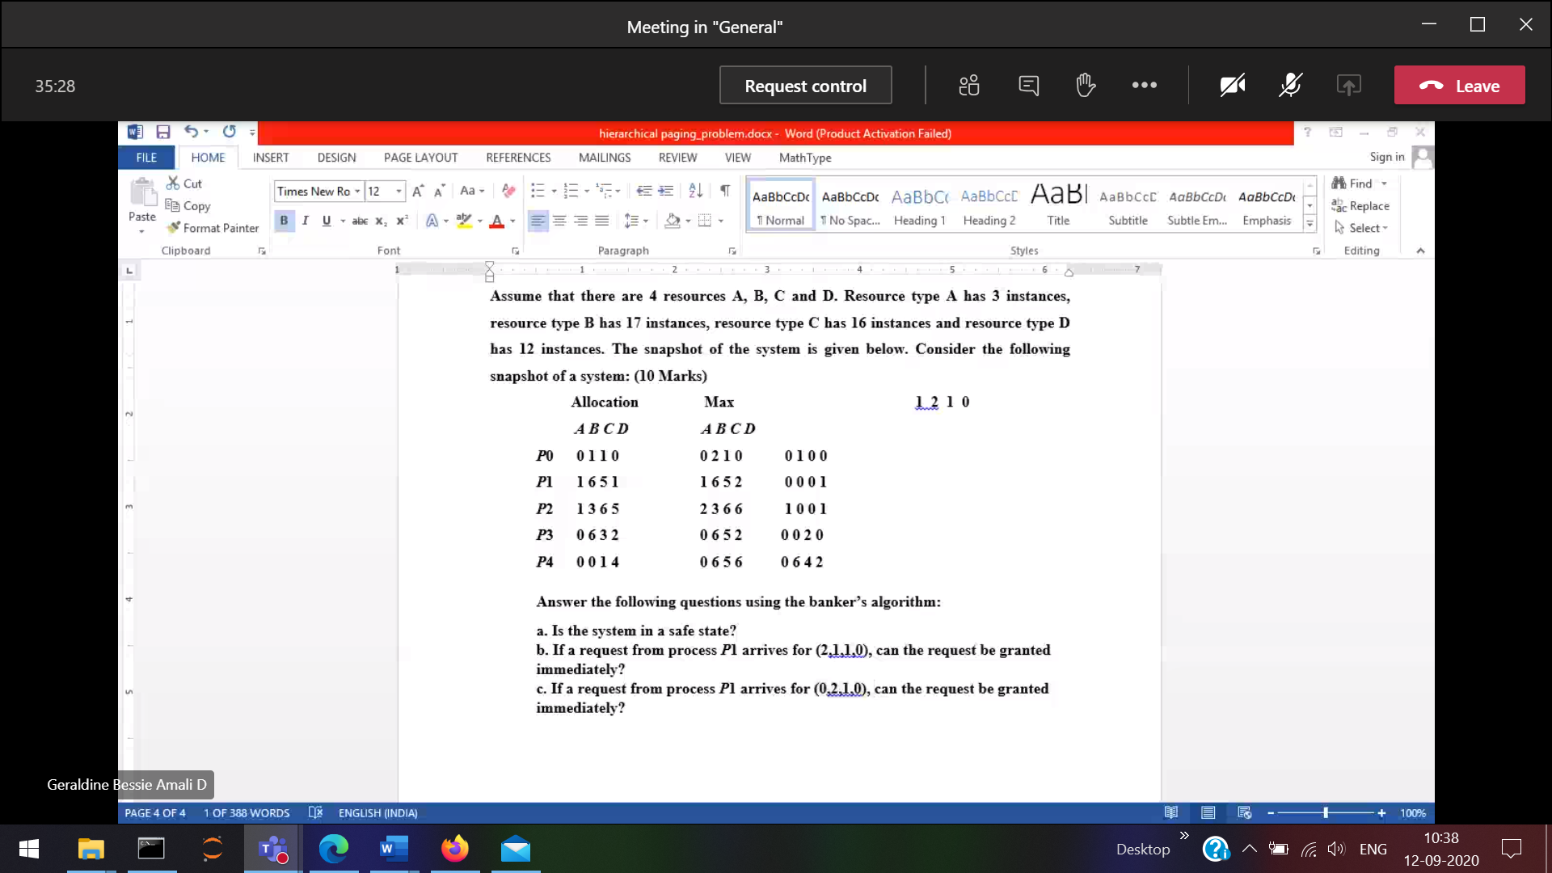

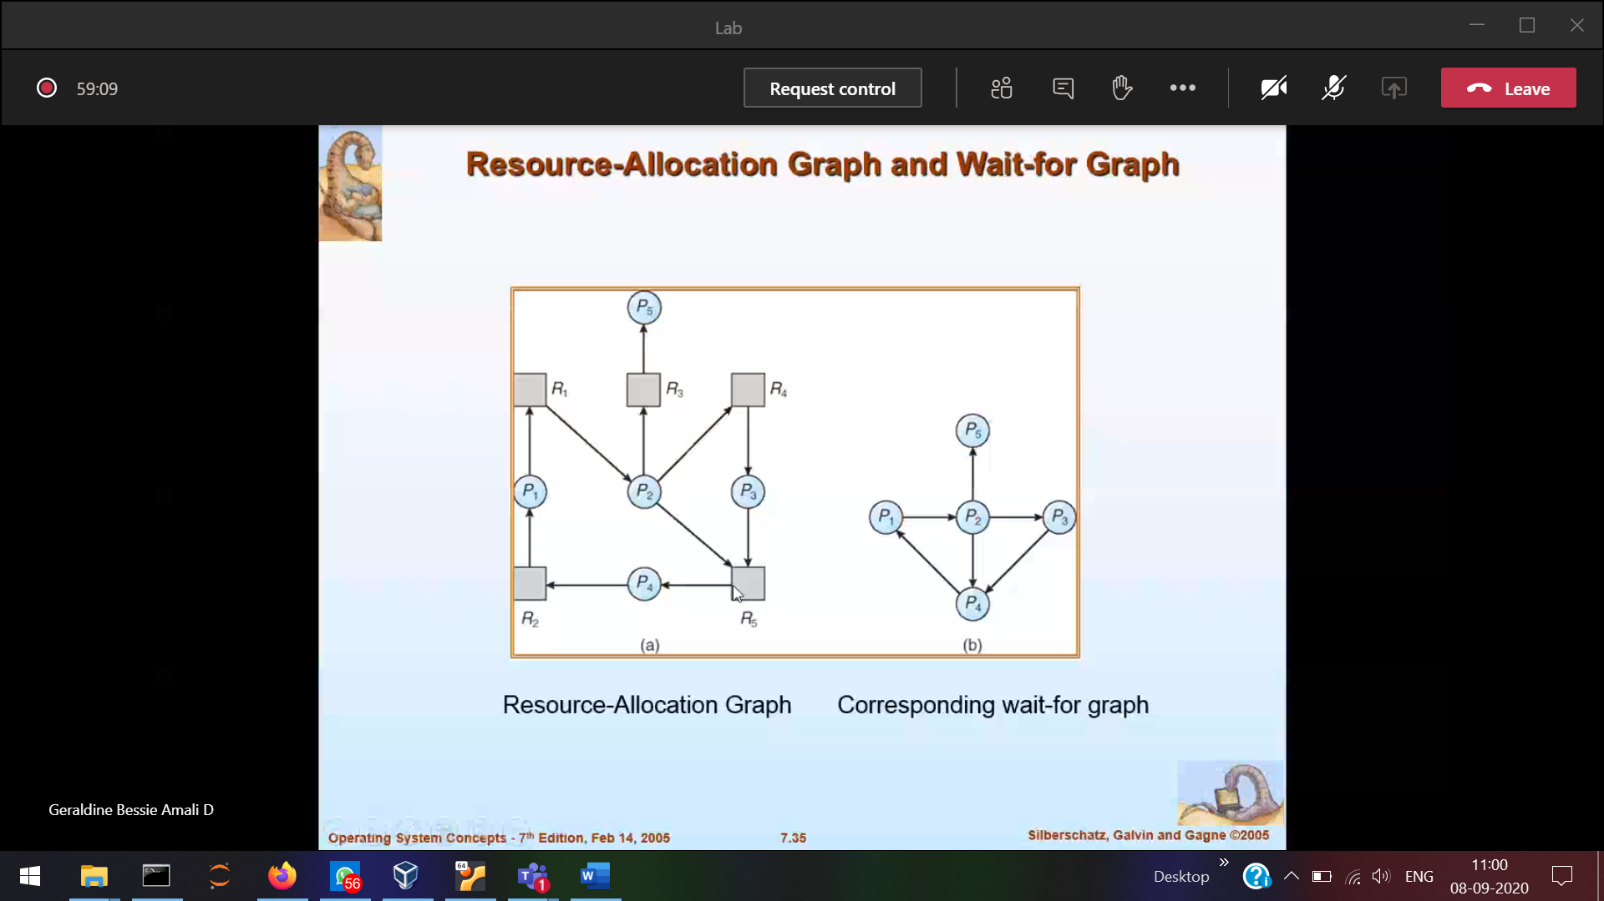

All the resources are removed in wait-for graph

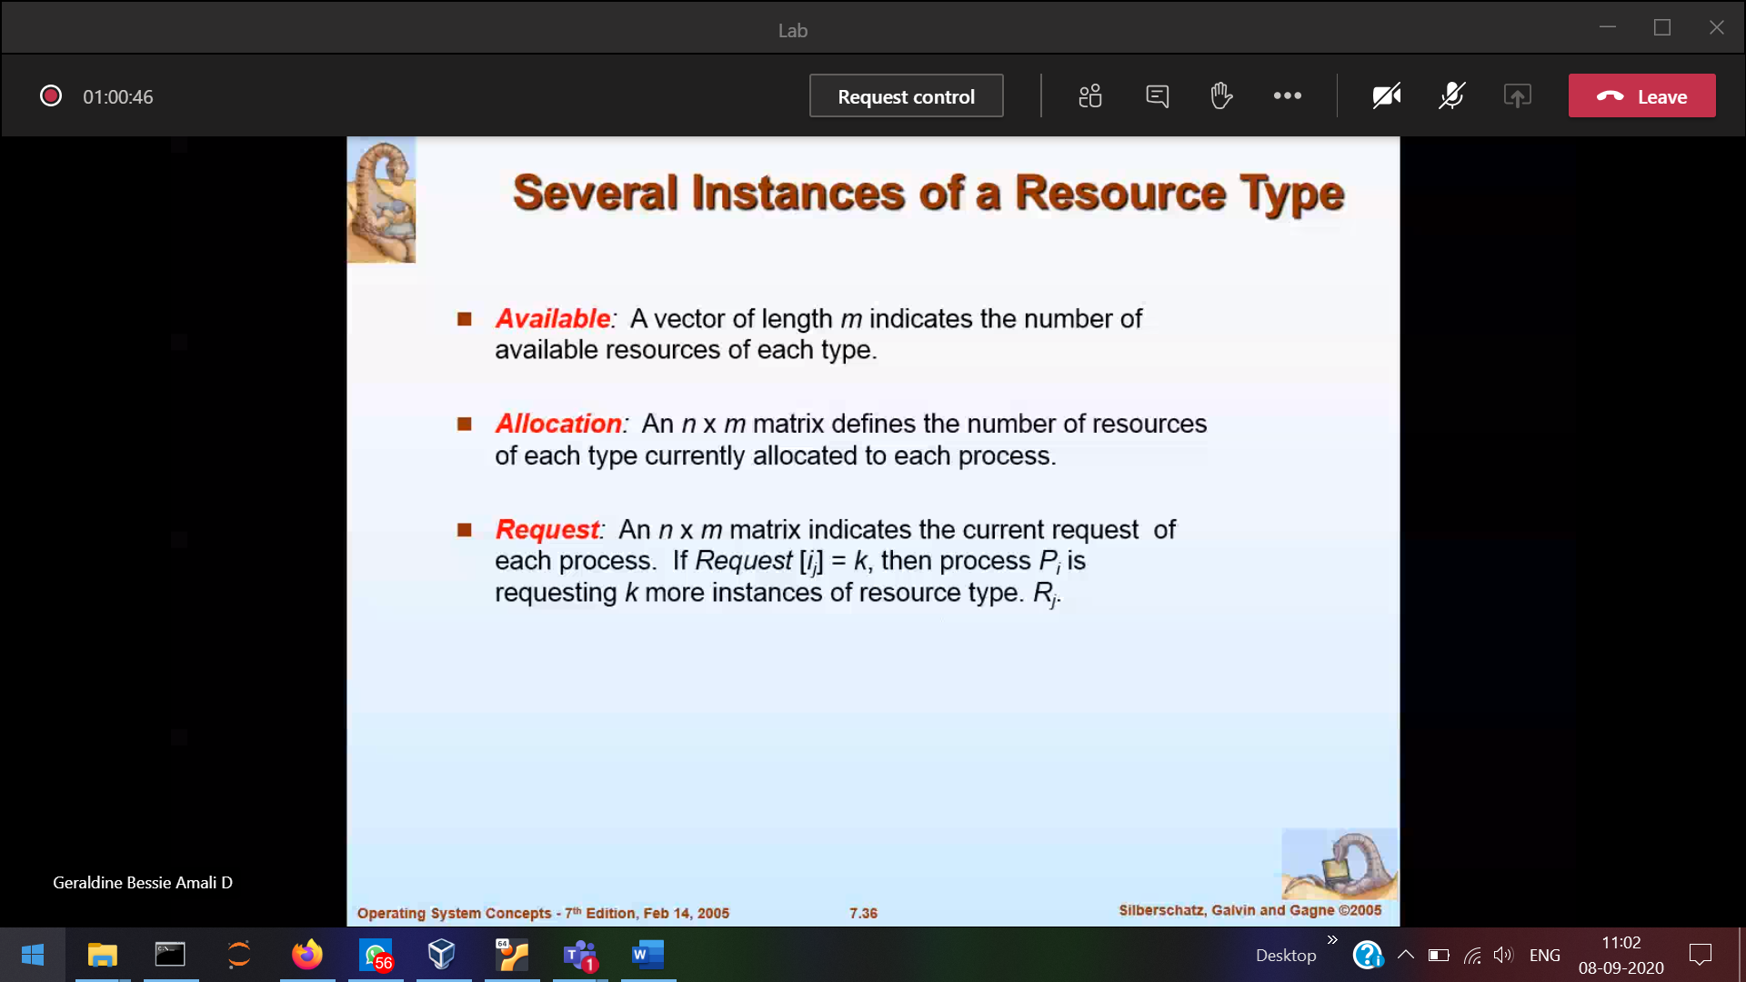

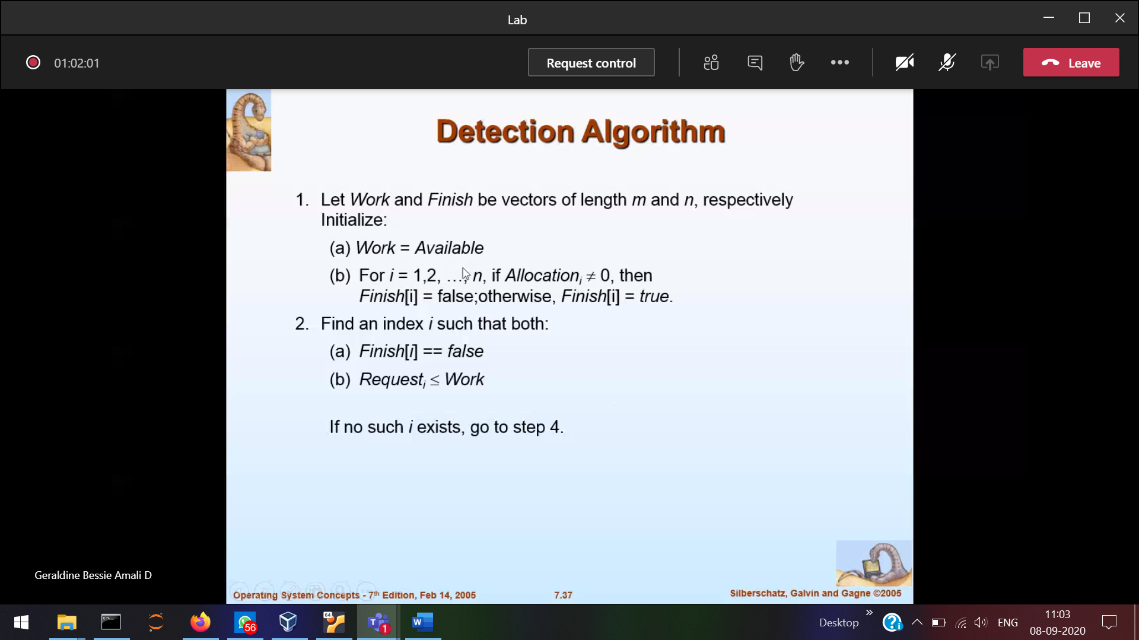

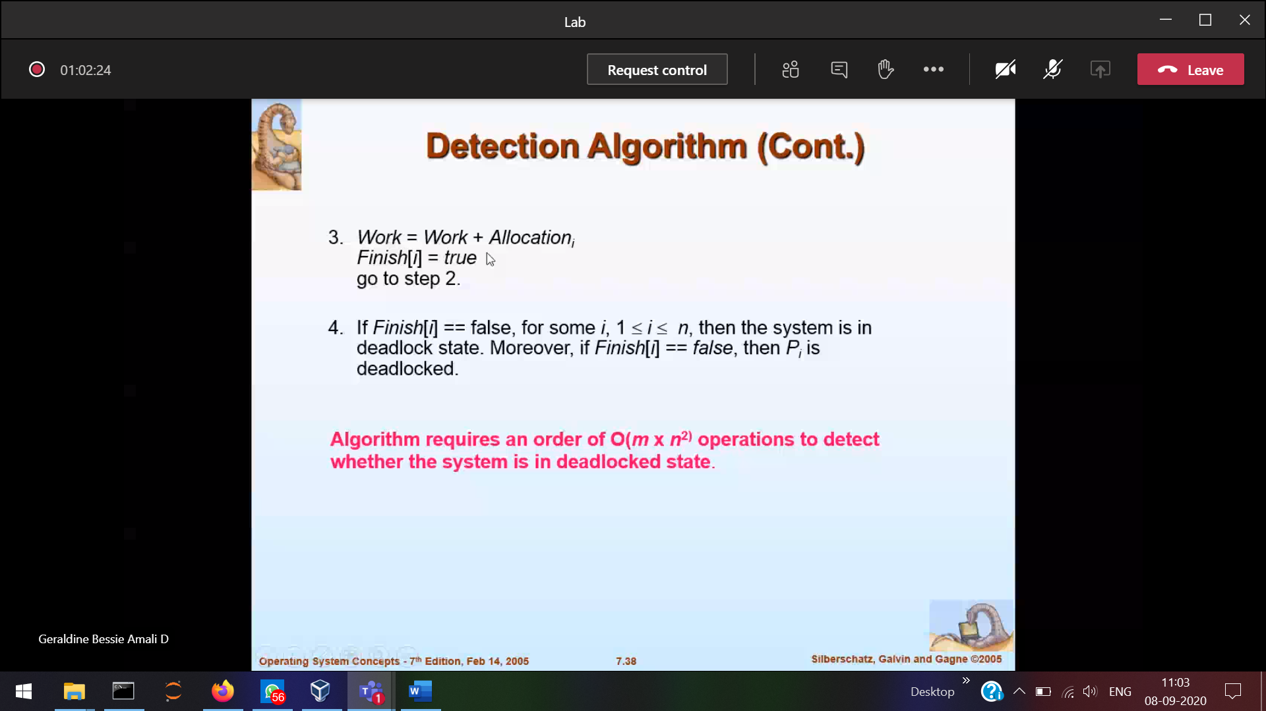

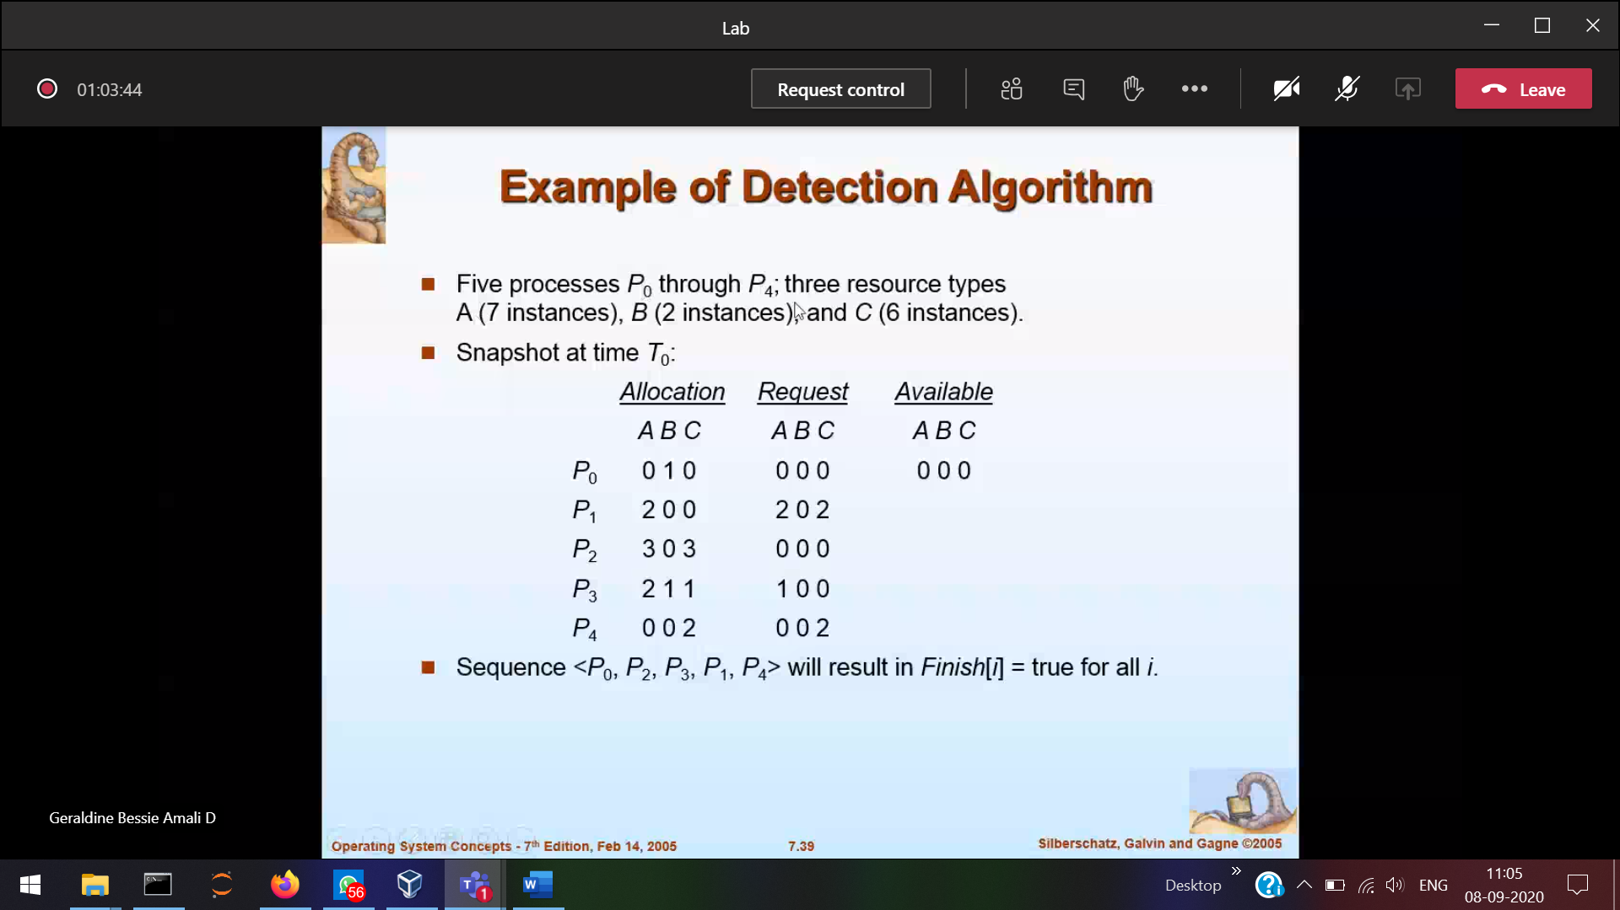

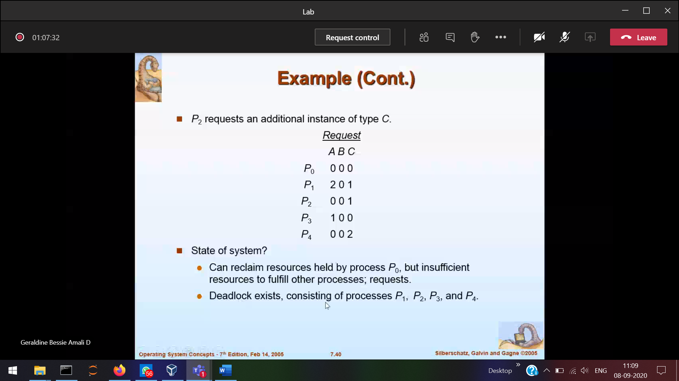

After deadlock what will you do

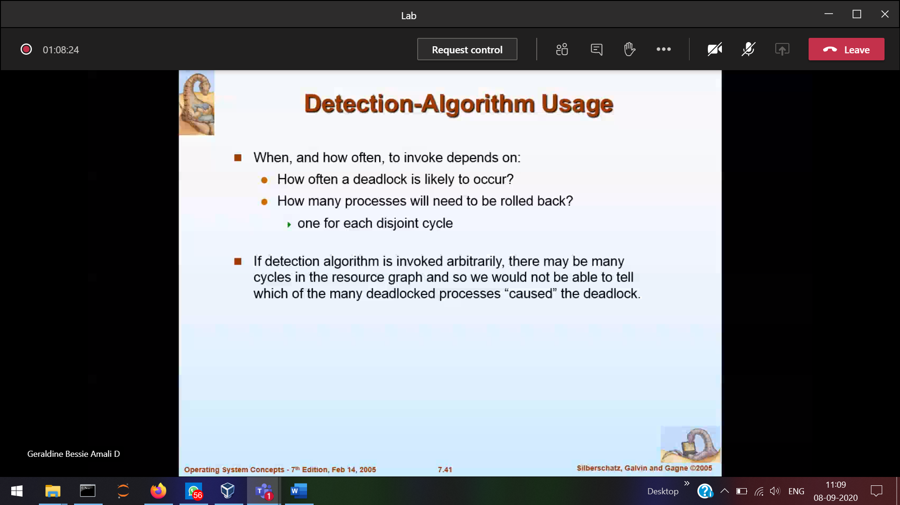

Should recover from deadlock

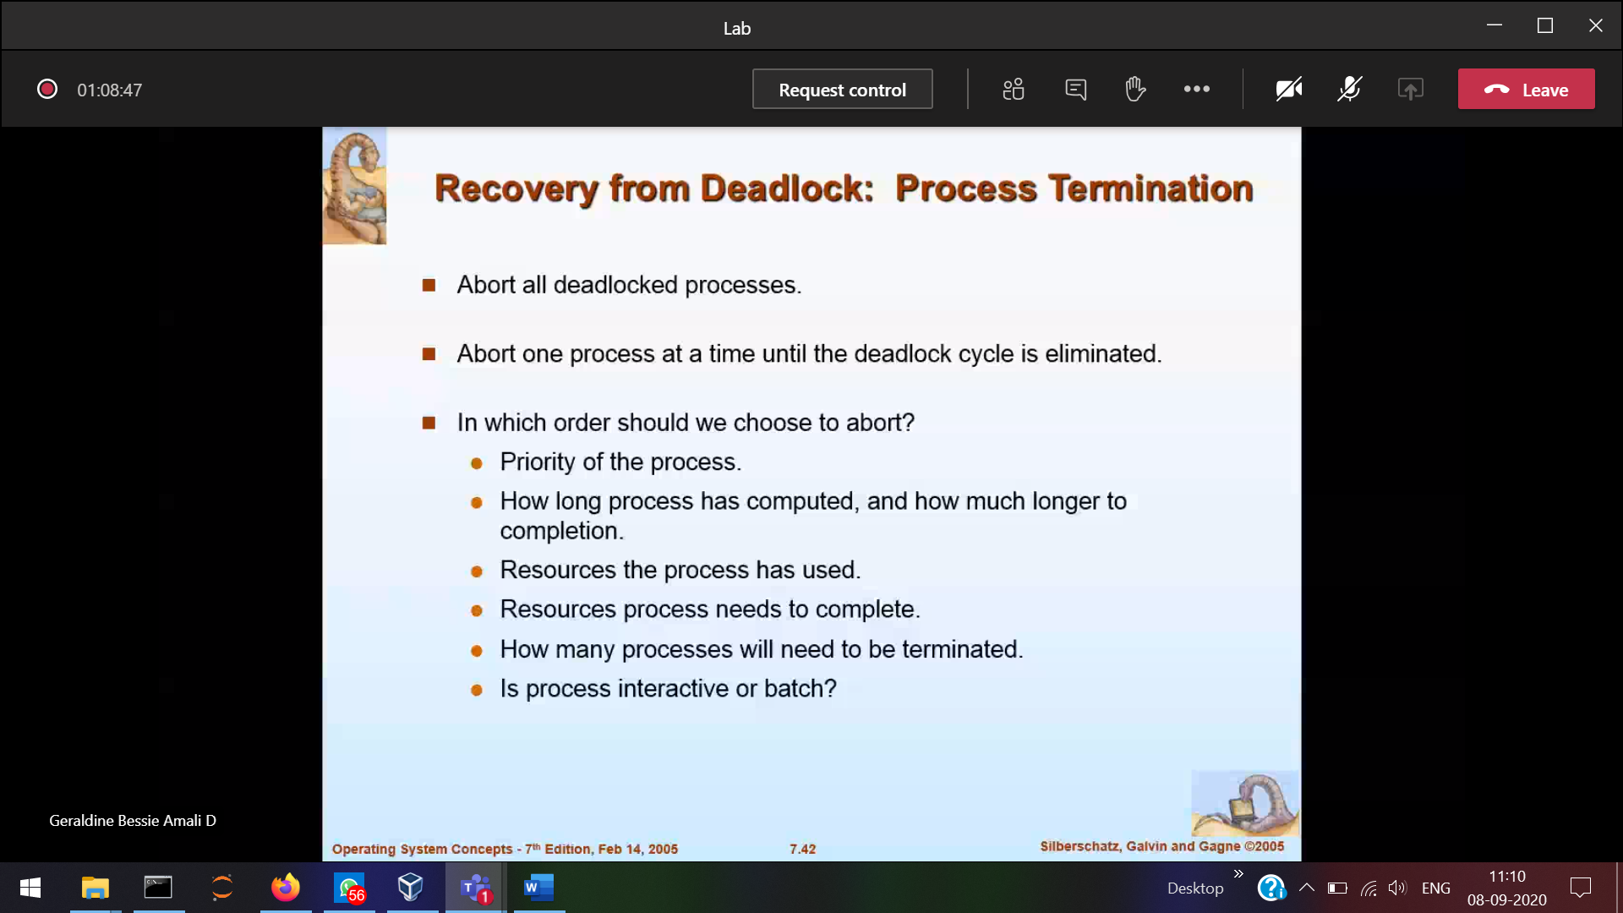

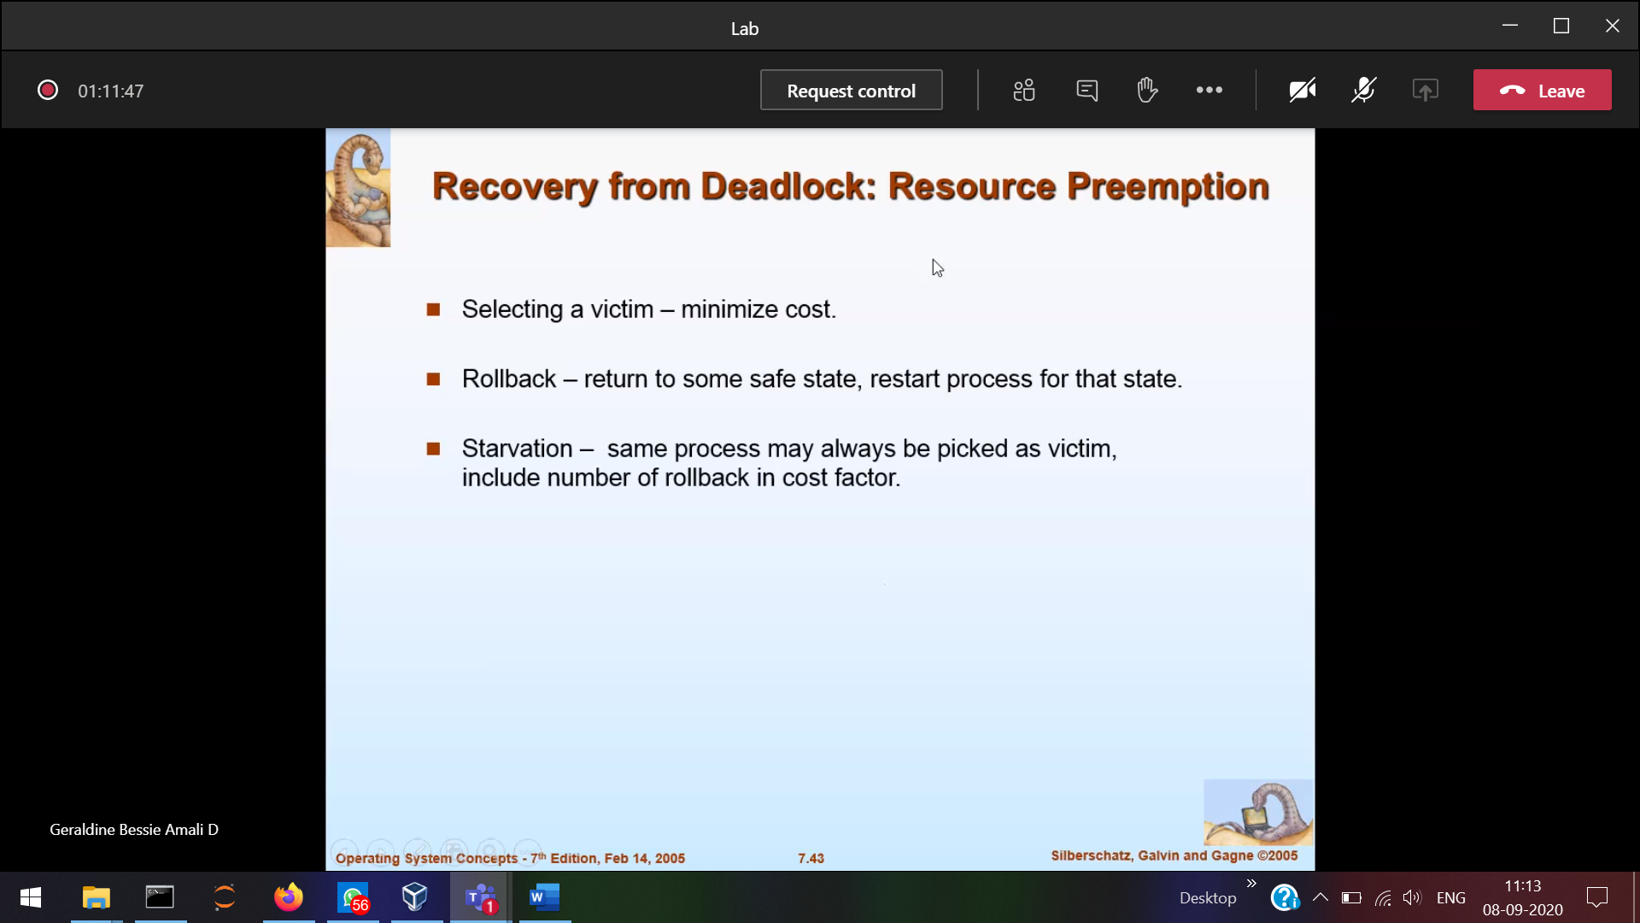

These are very extra work

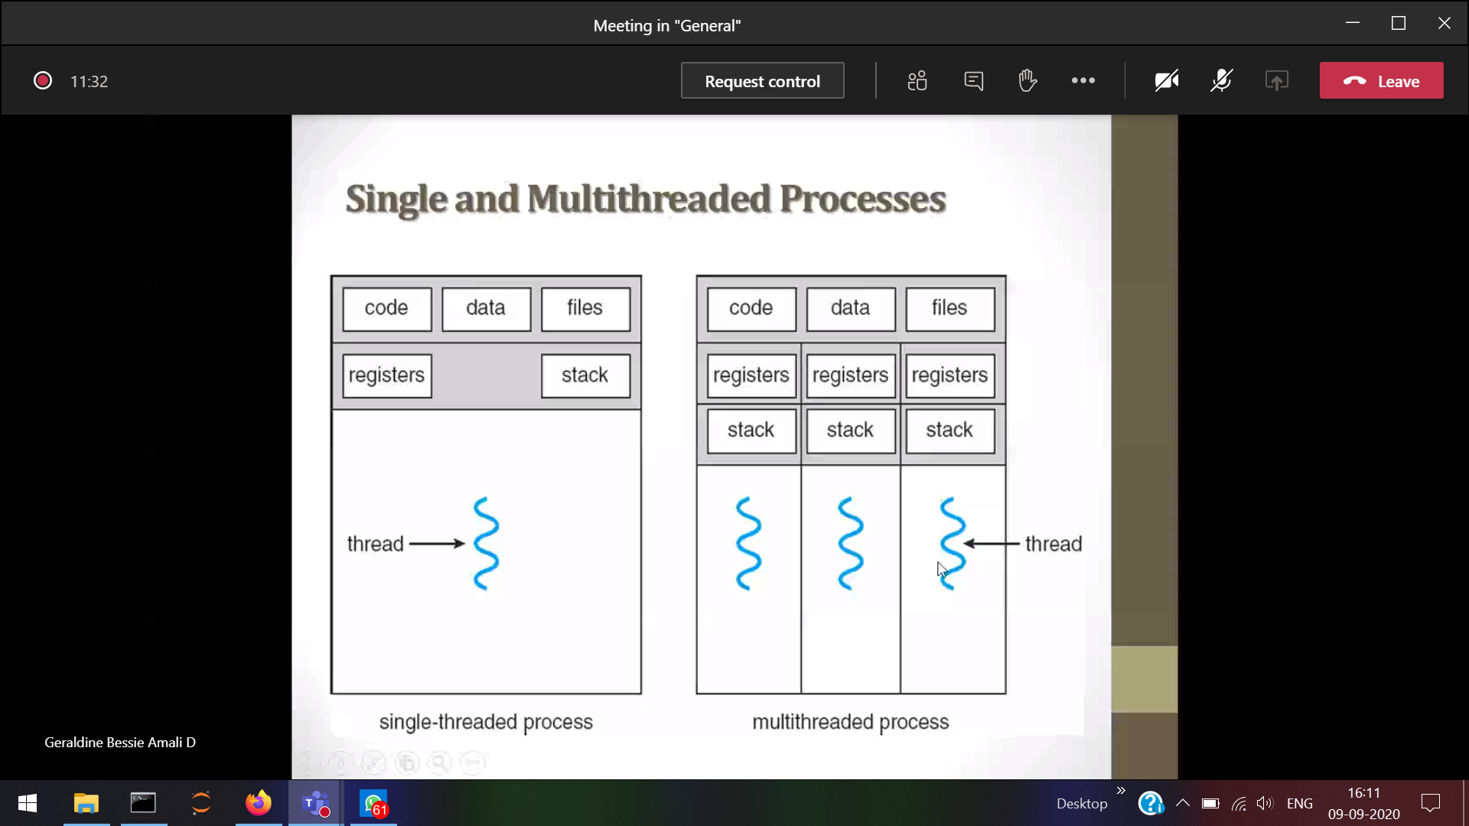

Single thread 1 process 🡪1 thread (if gone in blocked state) then other process should wait

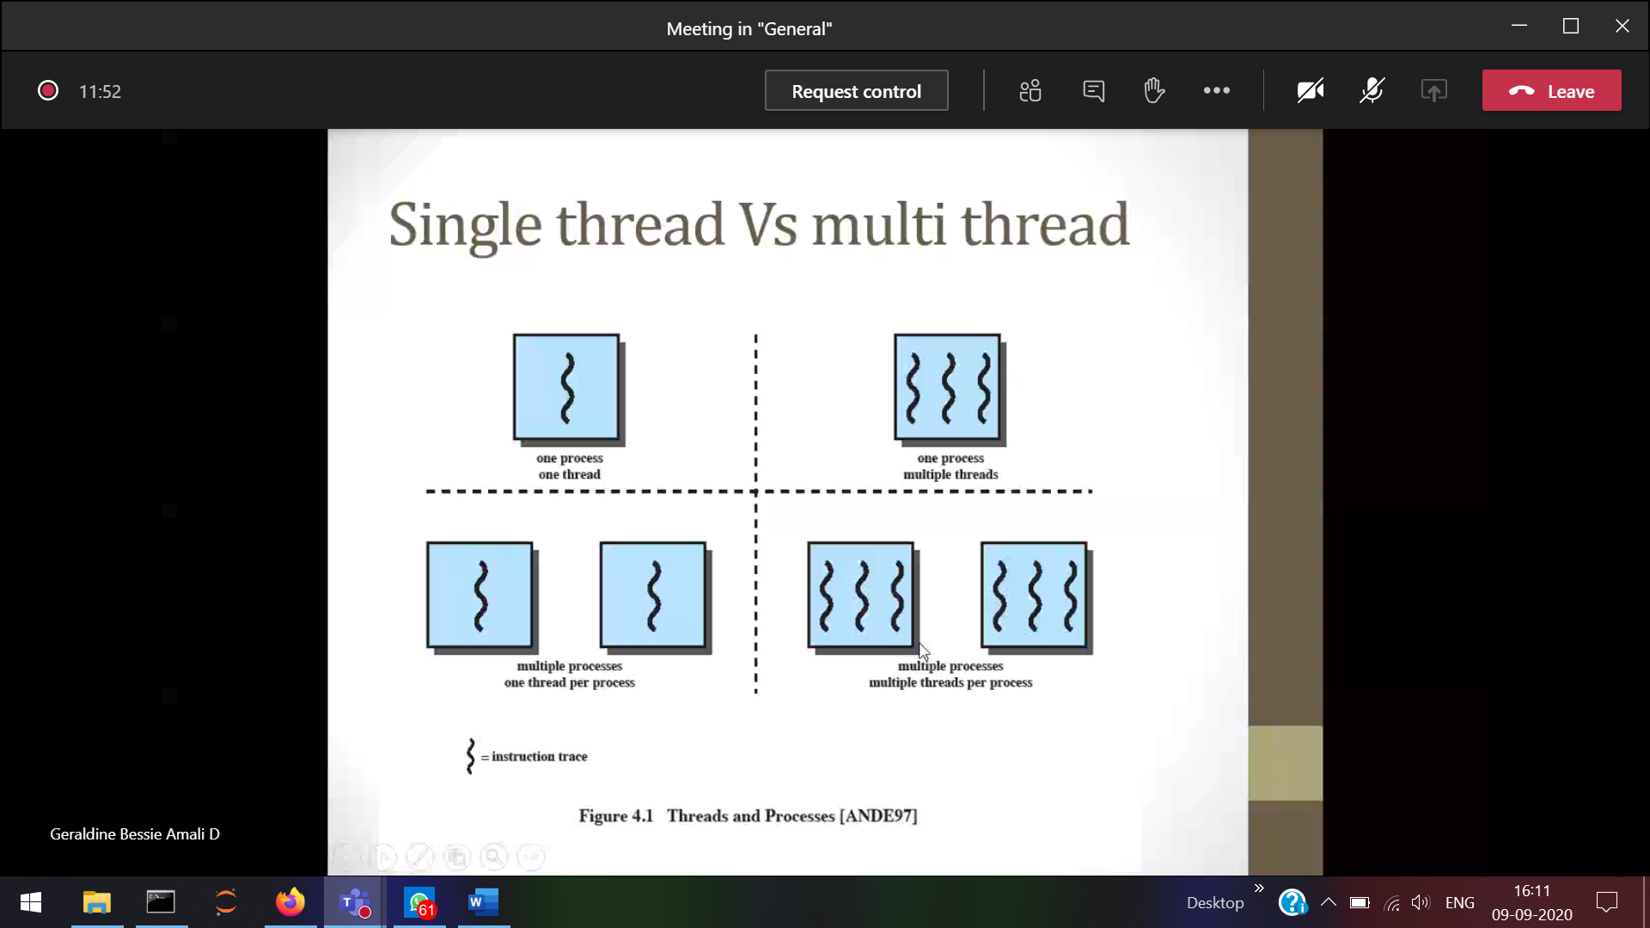­

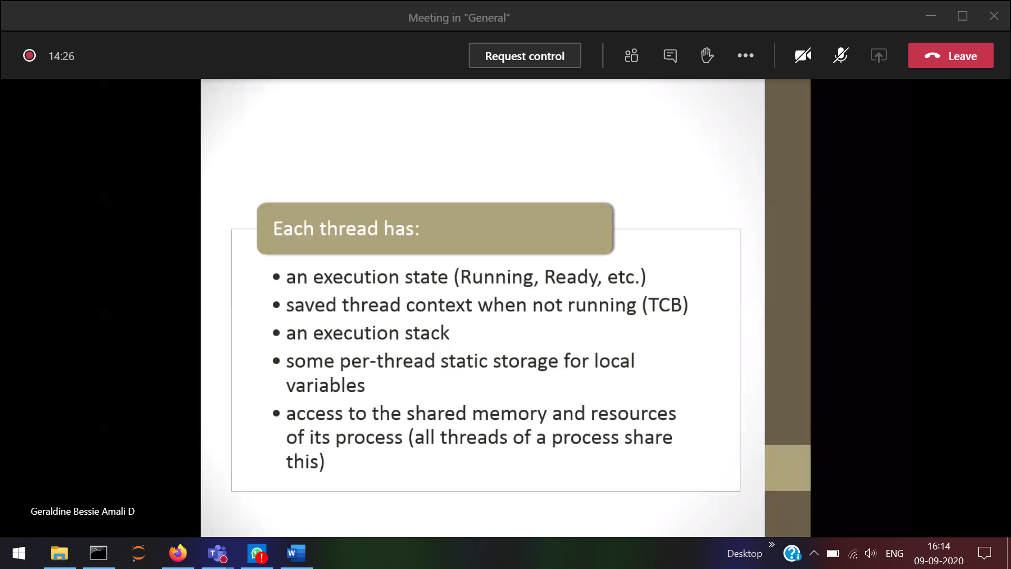

1 process 🡪 PCB 🡪 Multiple thread . Each and every thread will have its own PCB.

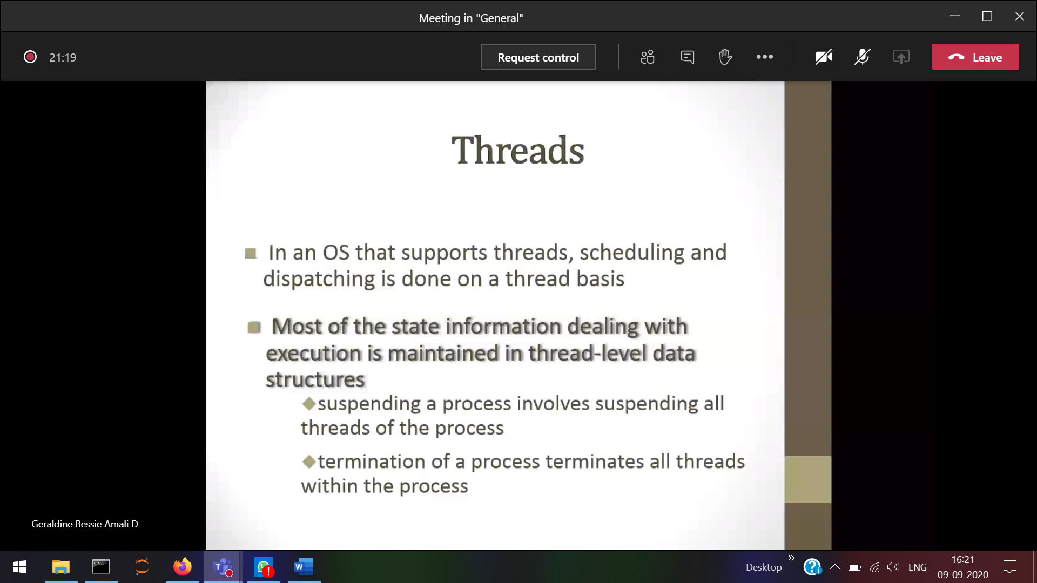If a process terminates then its respective threads will also be terminated

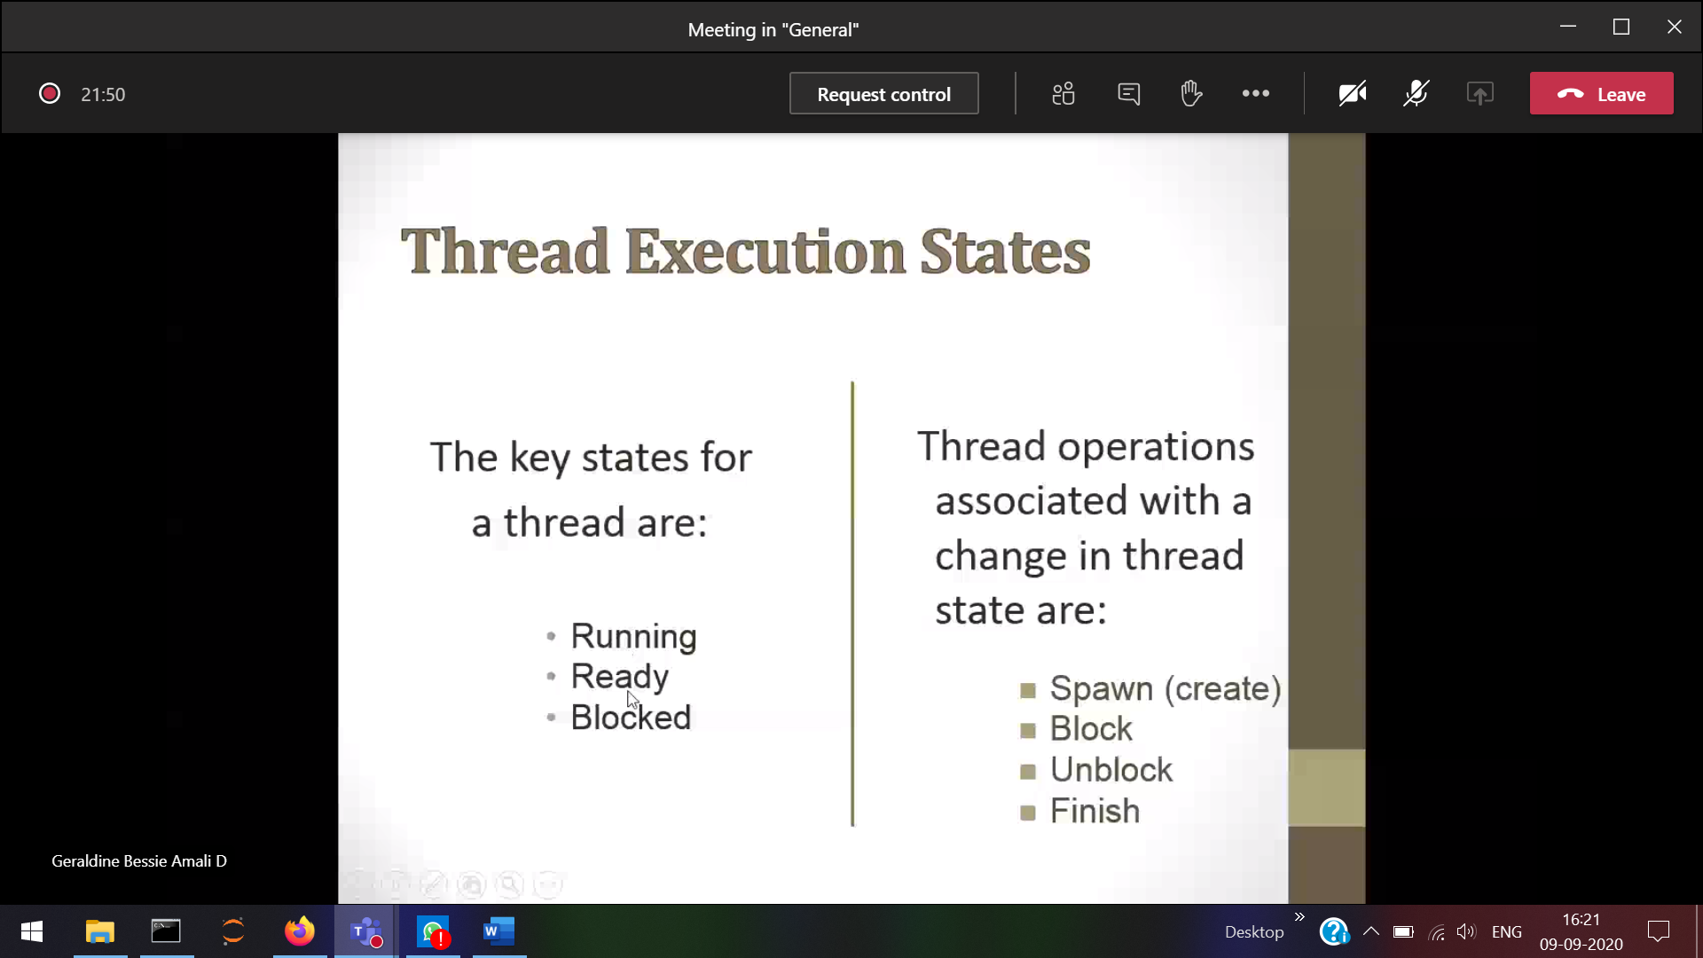

A thread can create another thread.  
A thread can block/unblock itself

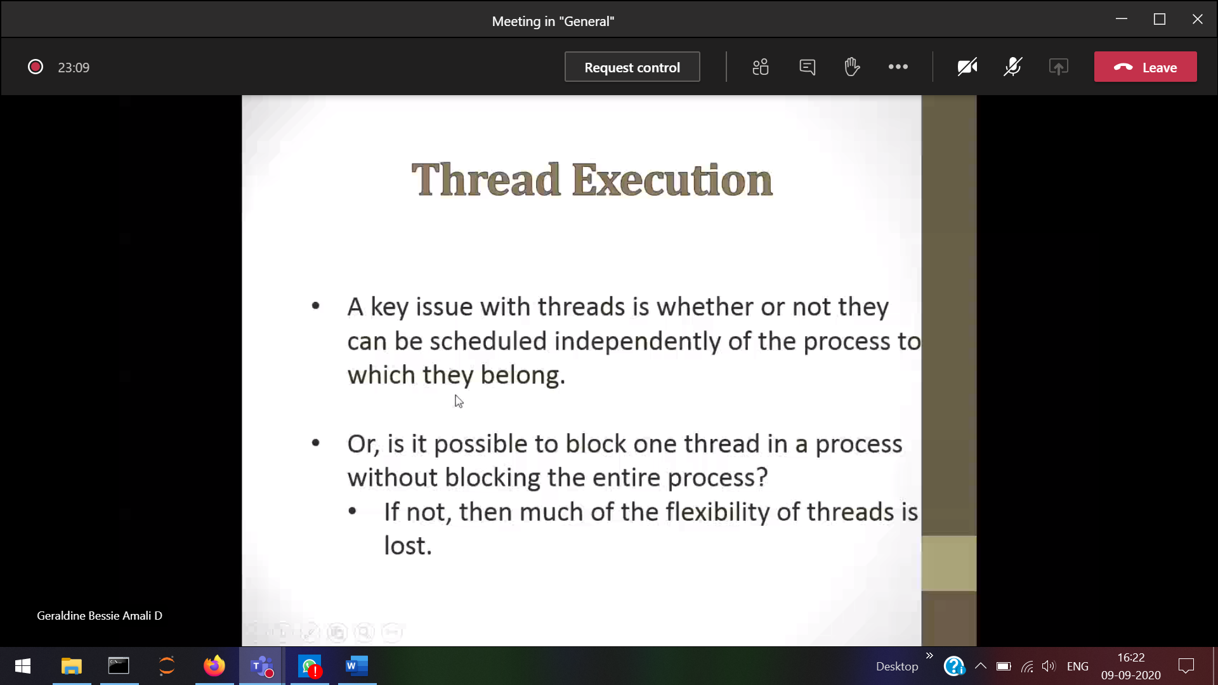

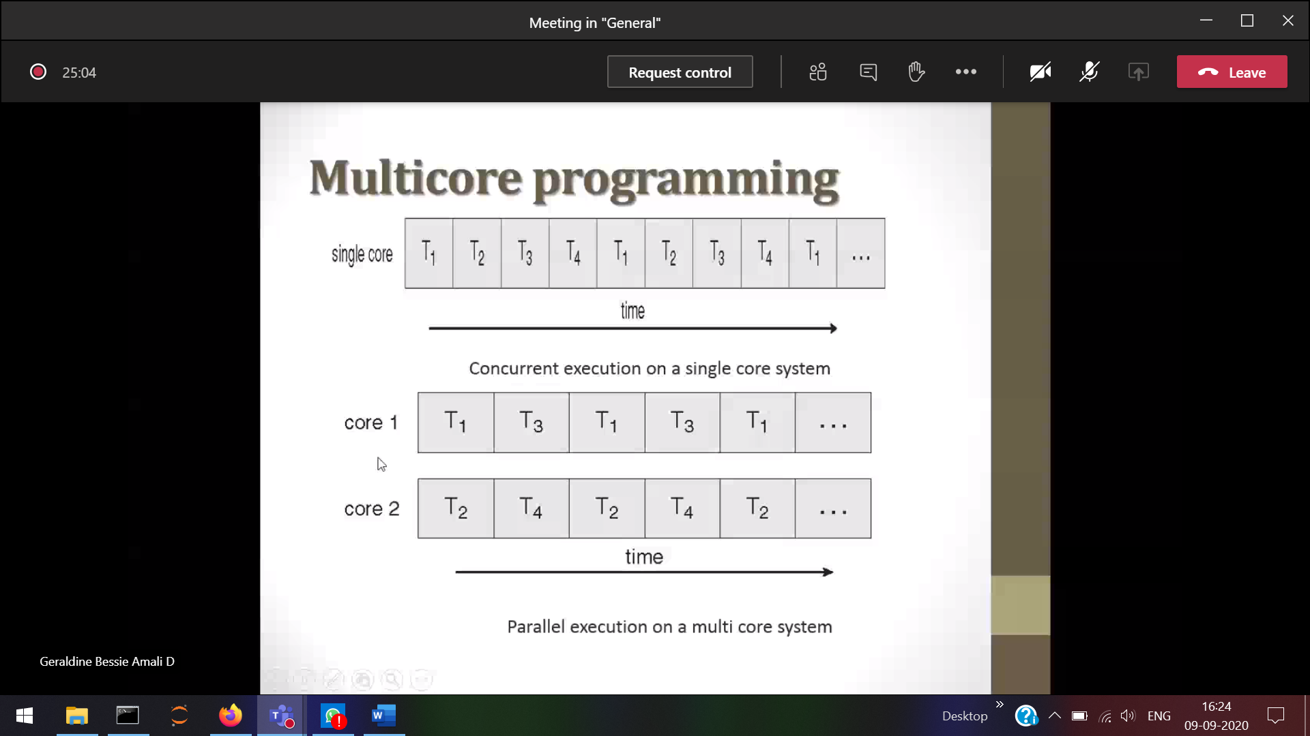

Single core 🡪 One process at a time

Multi-core 🡪 the threads can be scheduled

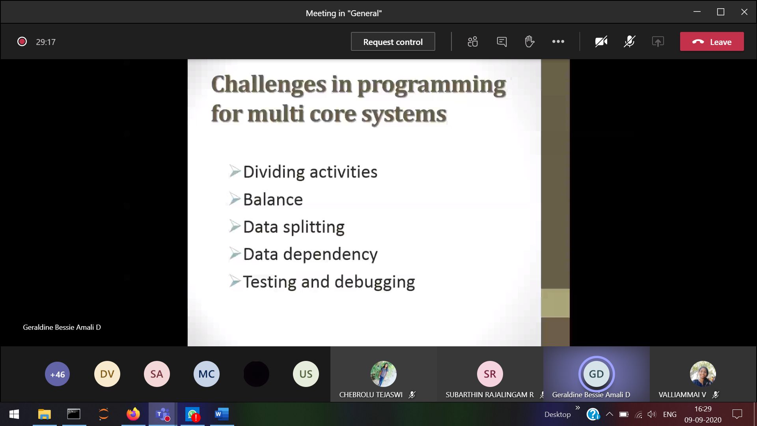

Crct balance must be done between the threads

Data dependency 🡪 1 thread should wait for the output of another thread

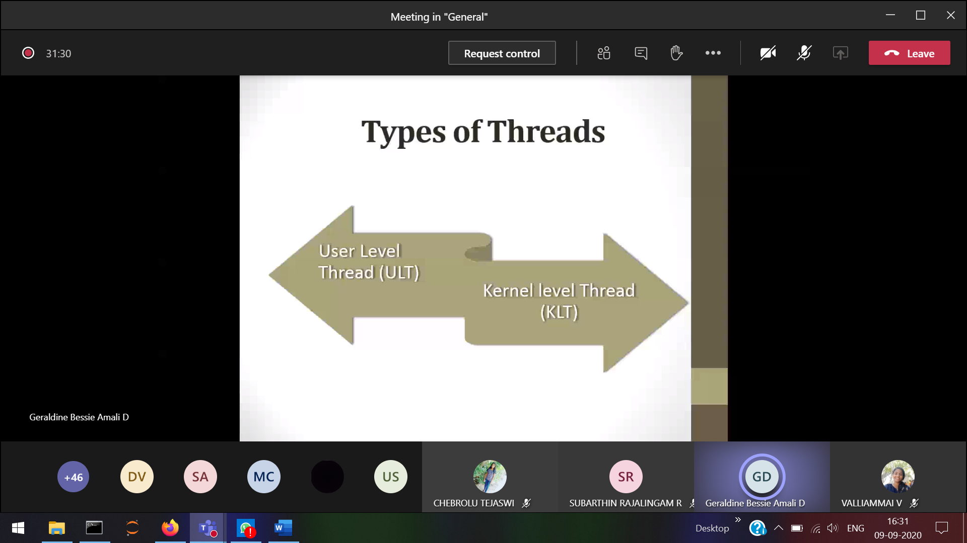

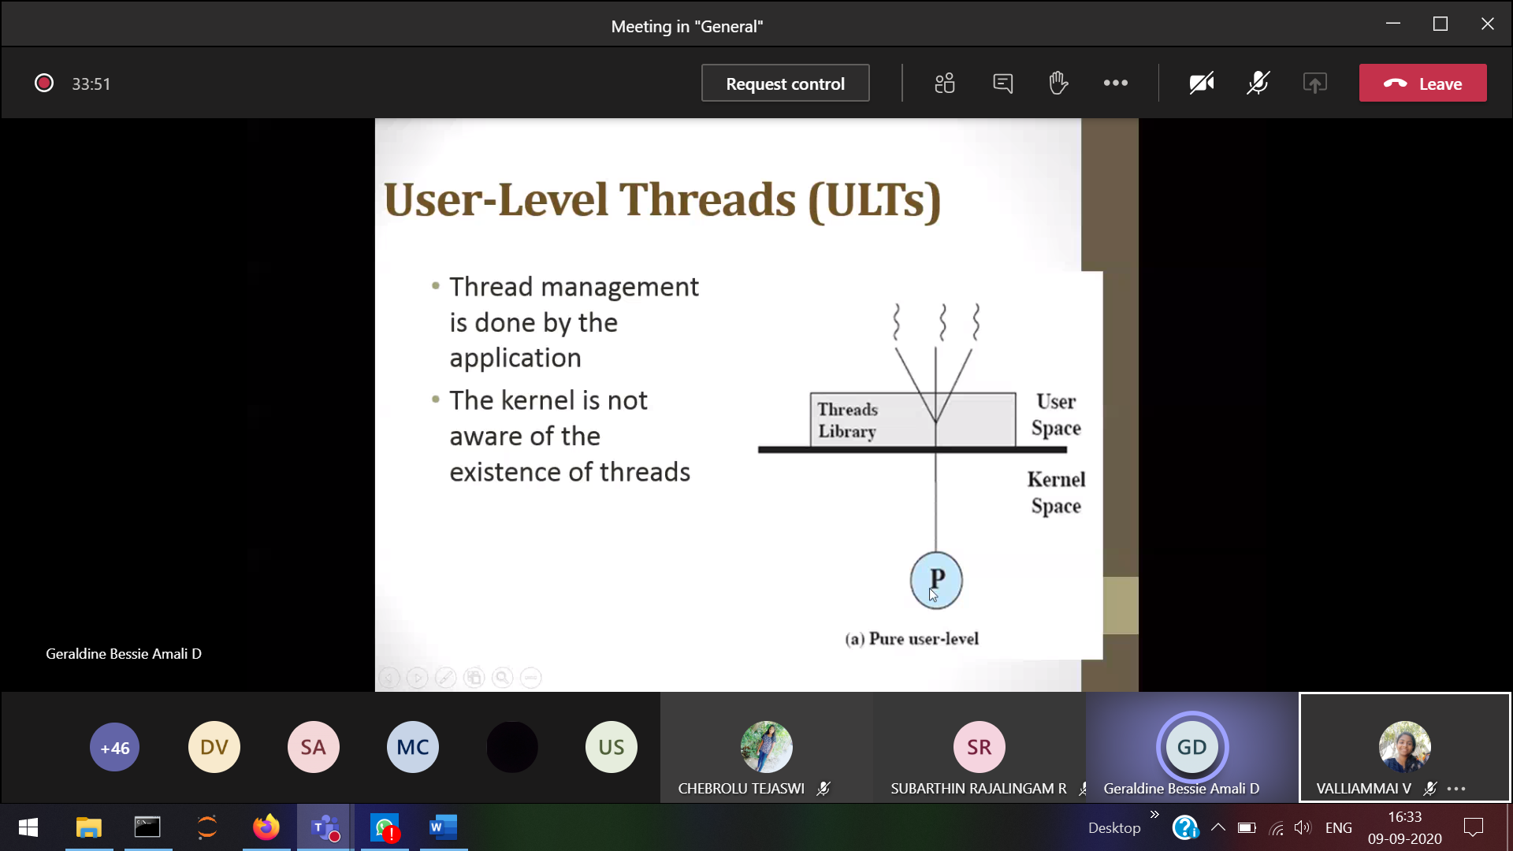

OS will look as a single process (actually thread is running)

Thread switiching takes place in the user mode itself, no required for kernel mode. Only 1 thread can execute at a time

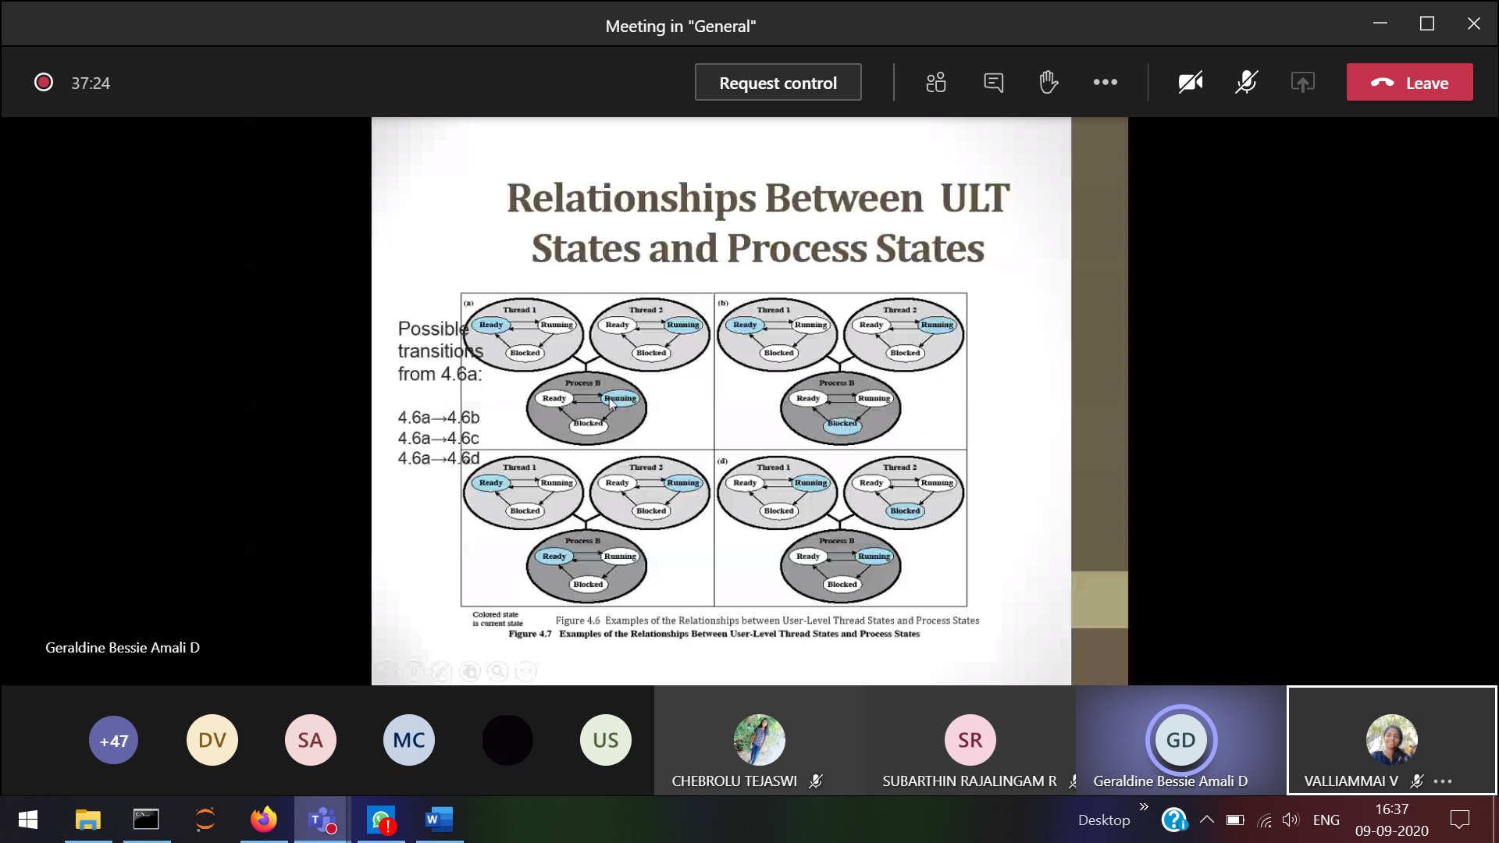

1. 2) P is blocked **3) P is running**

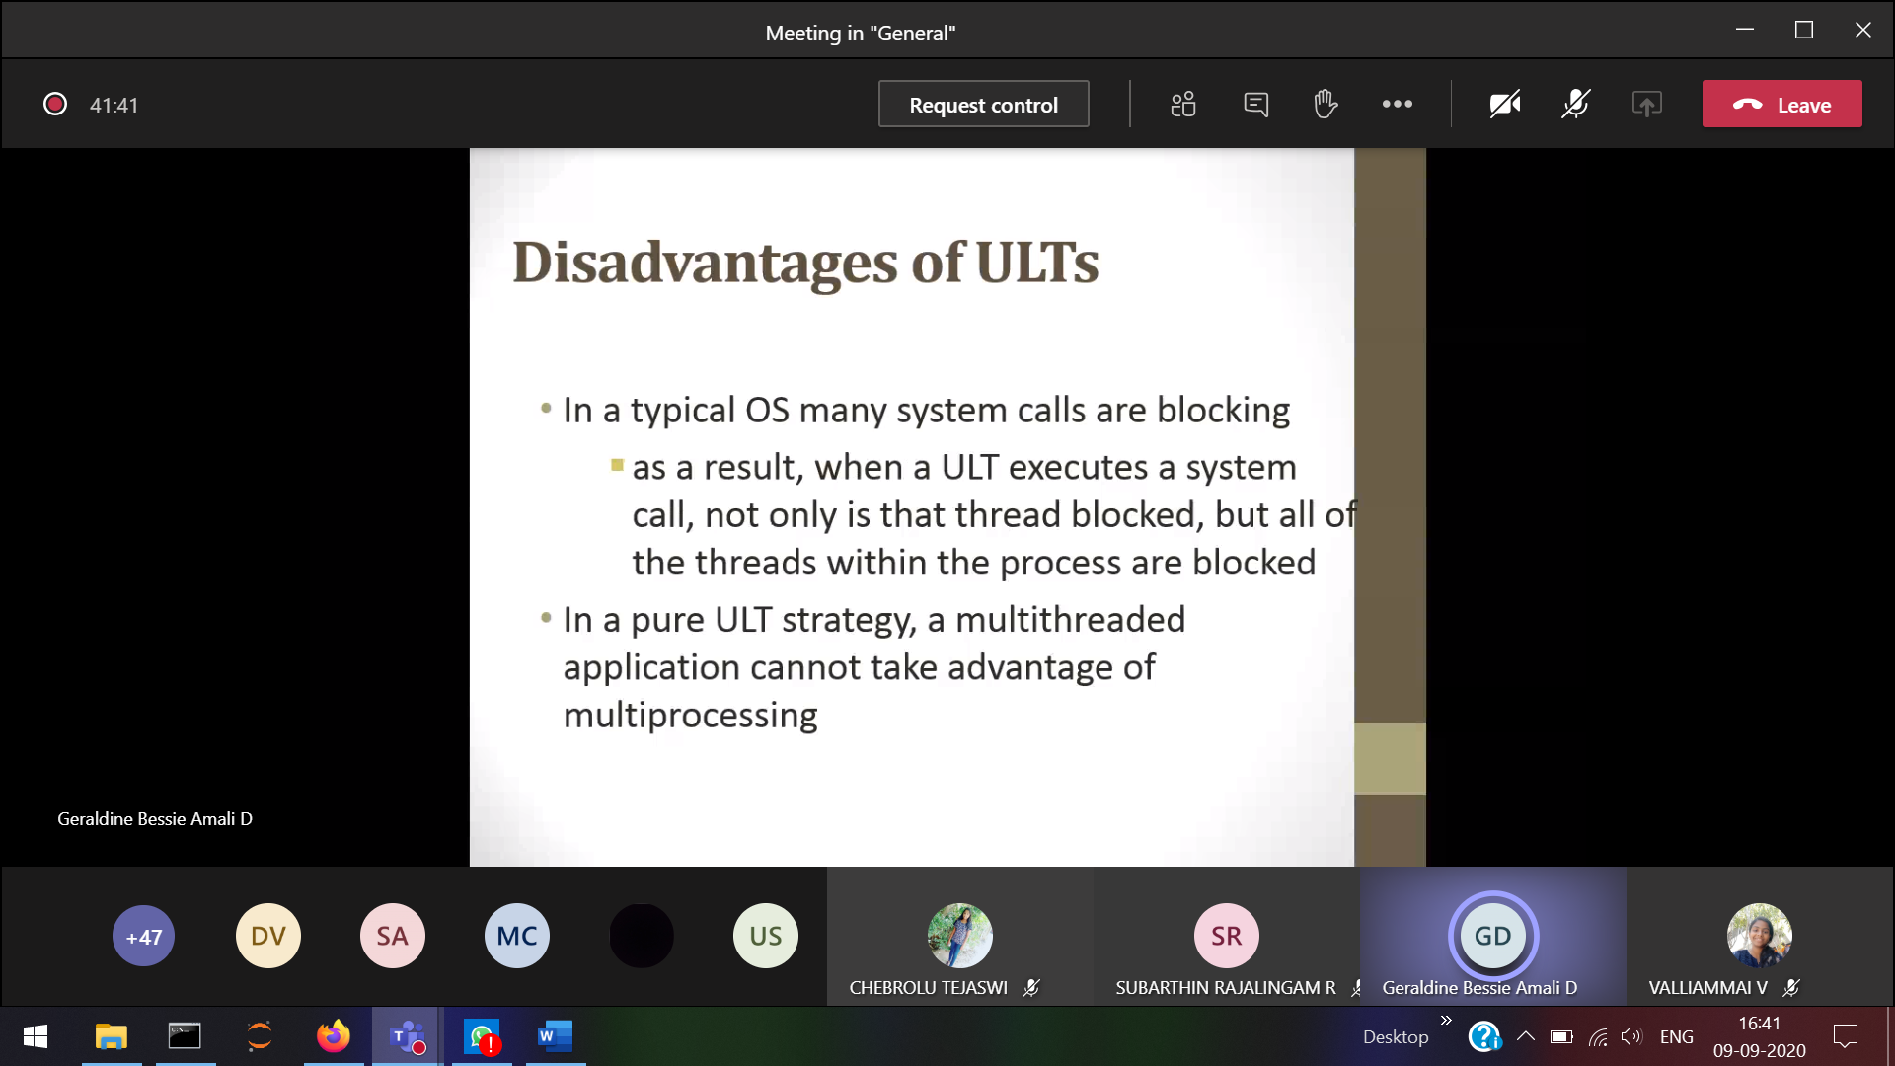ULT cannot use multiple cores

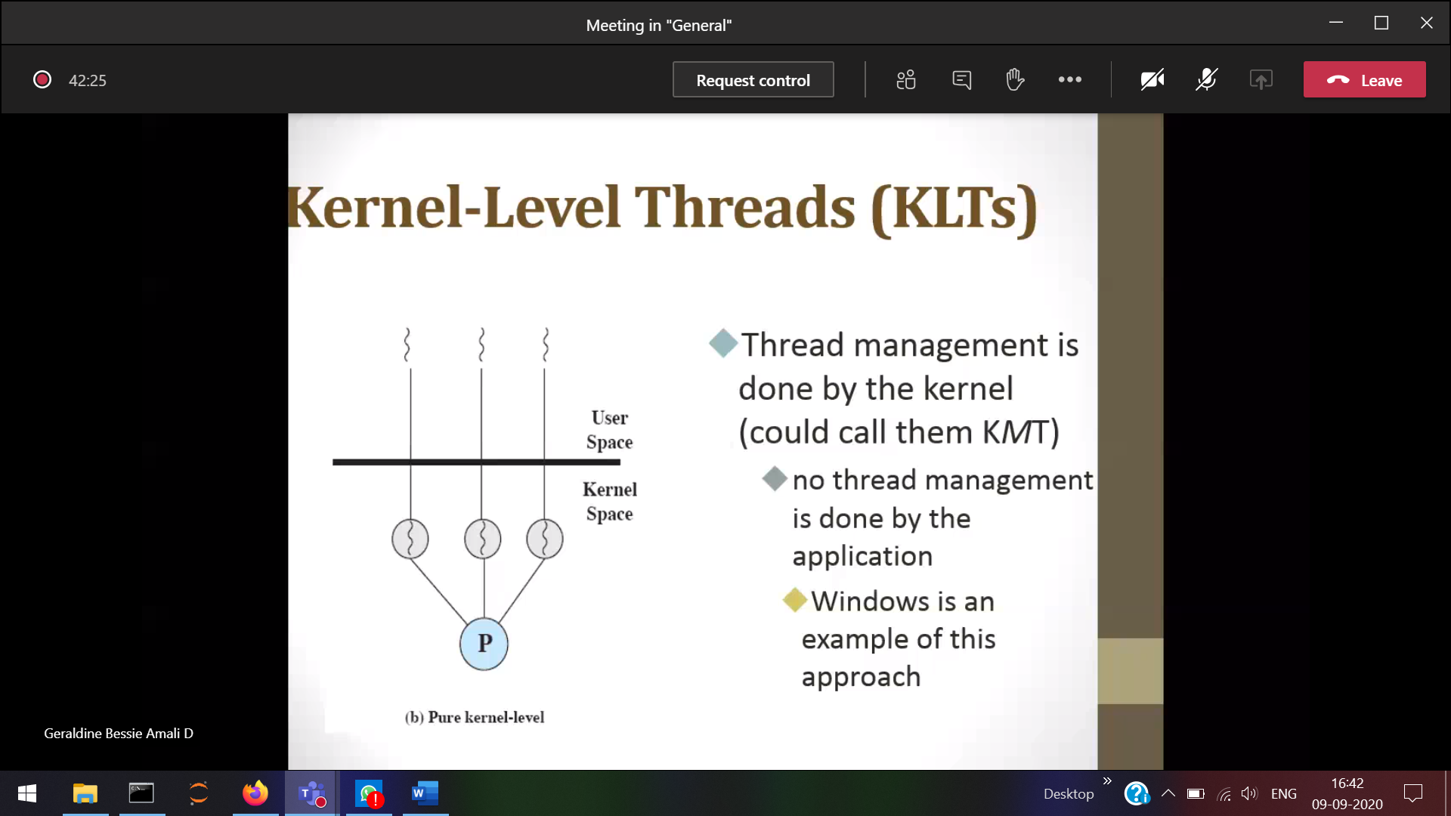

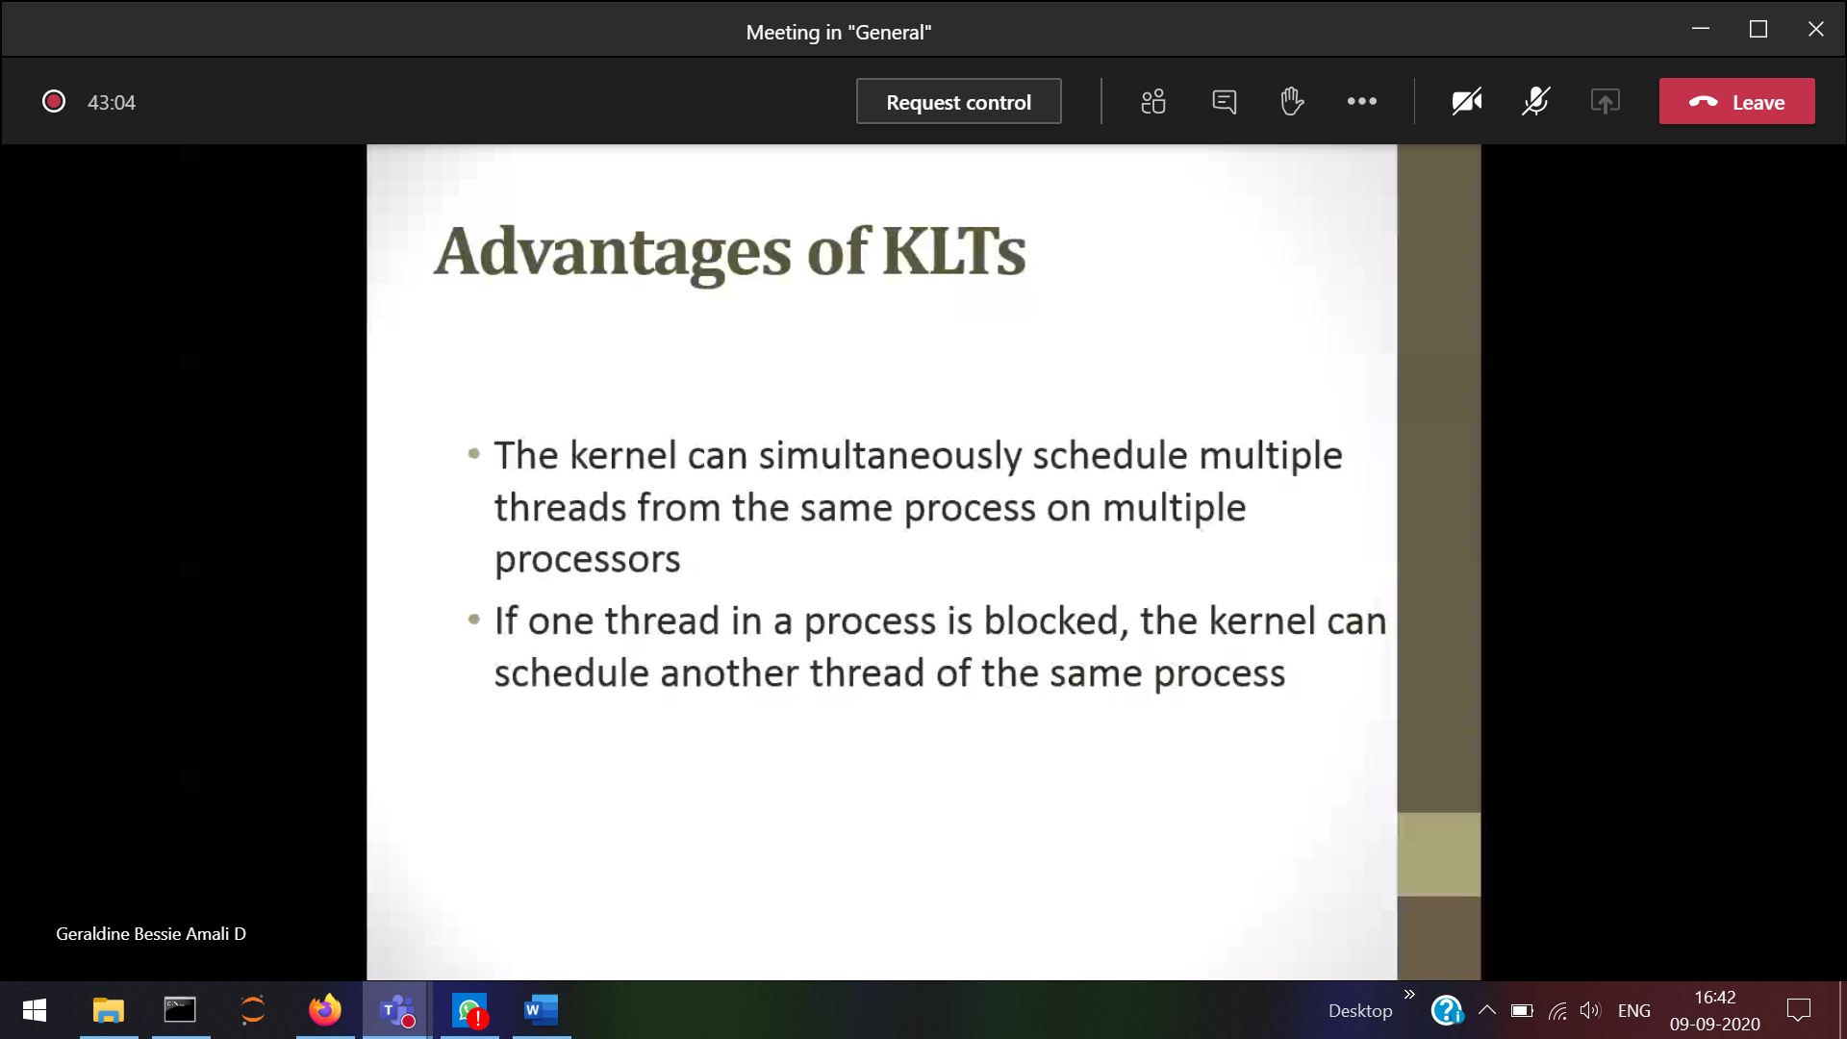

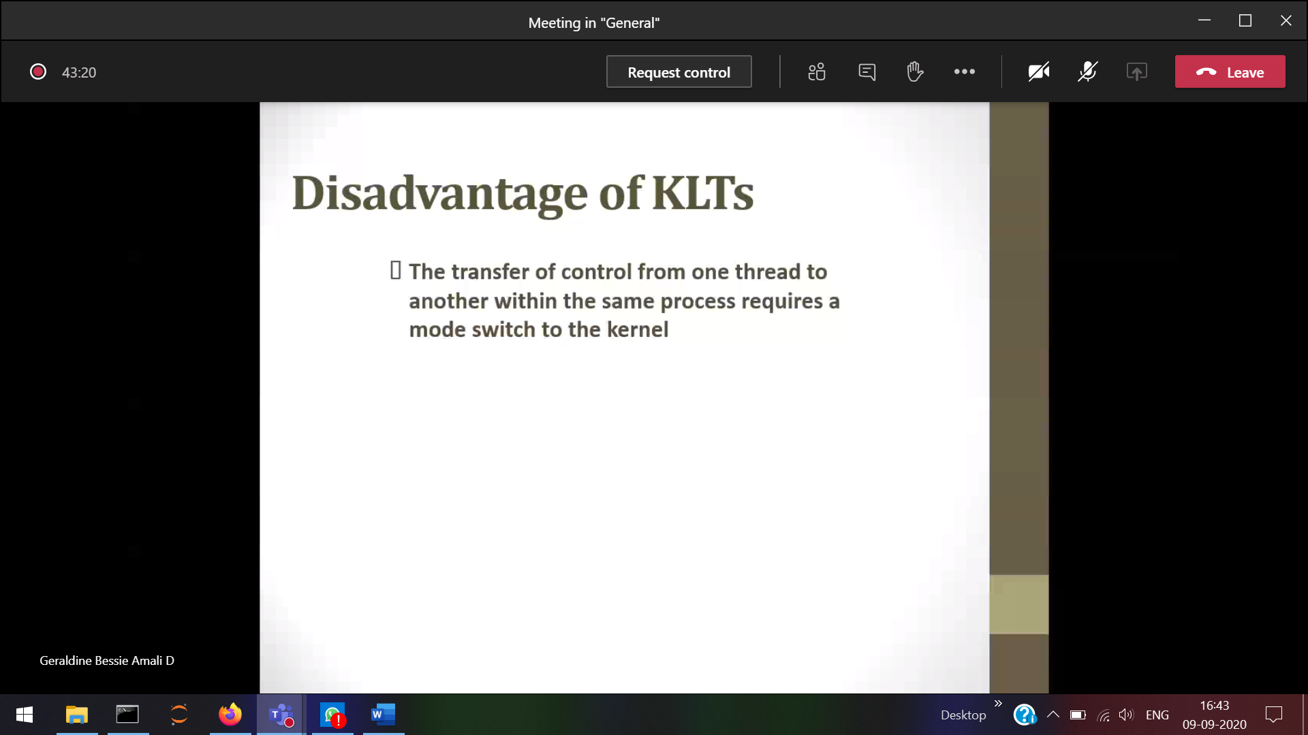

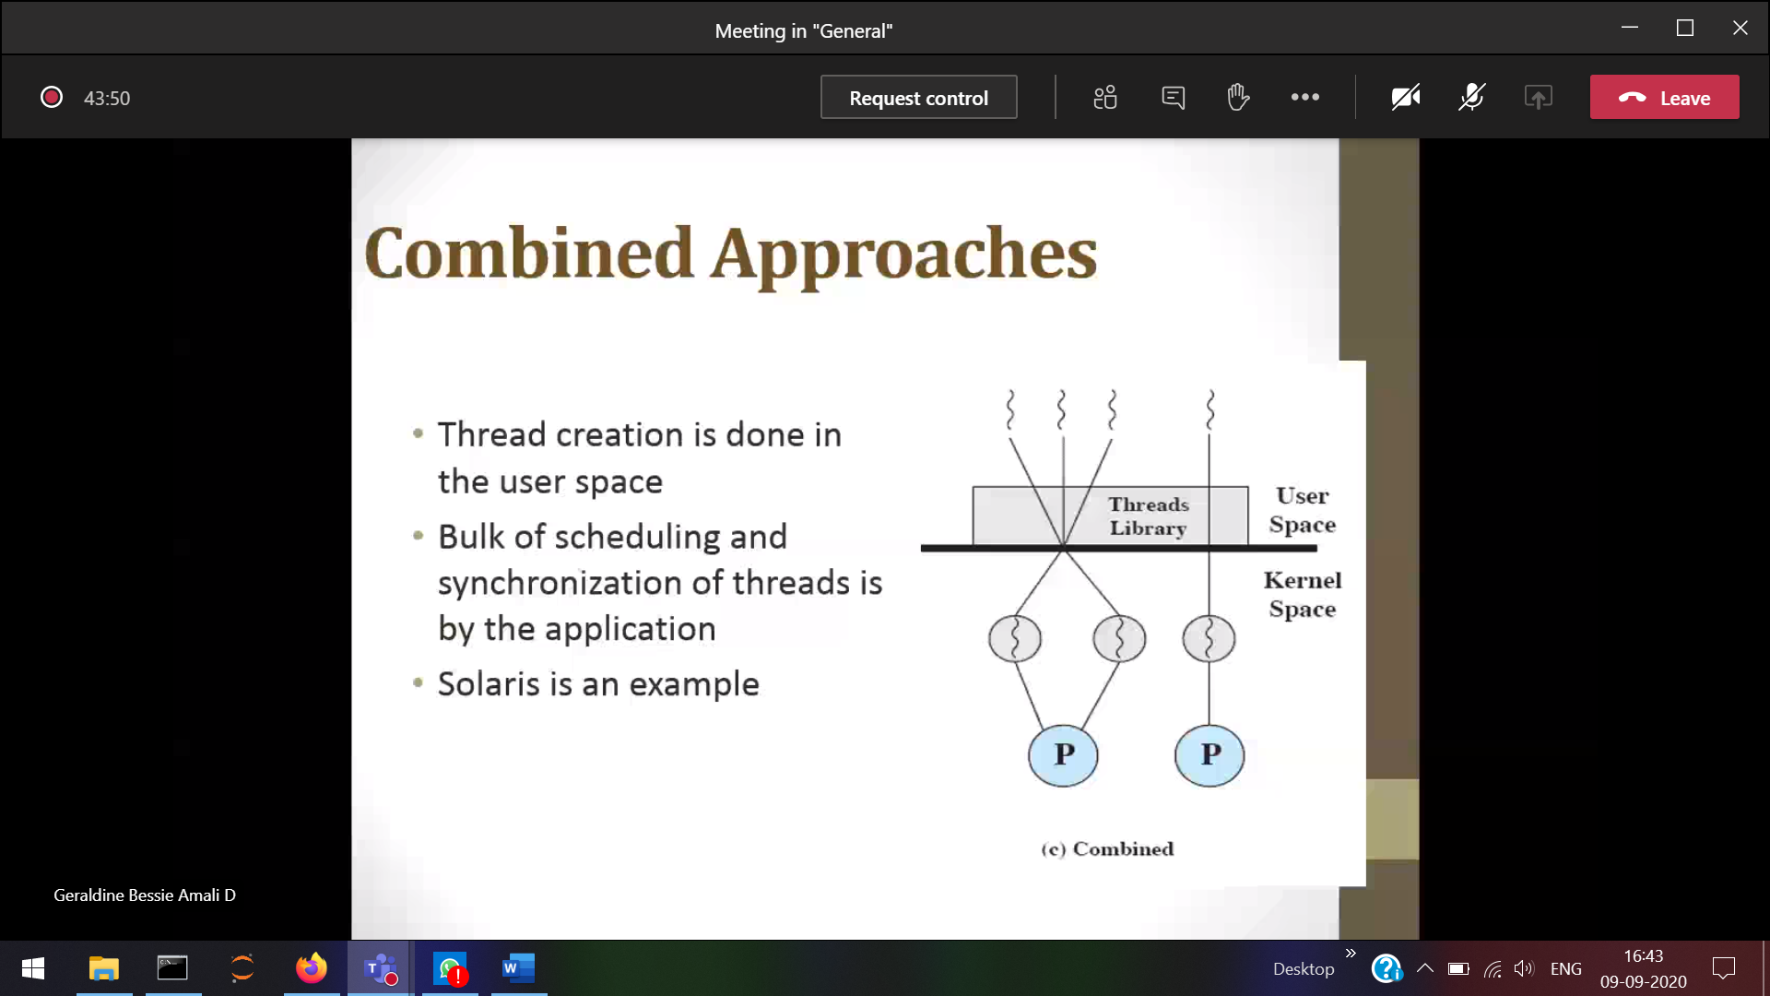

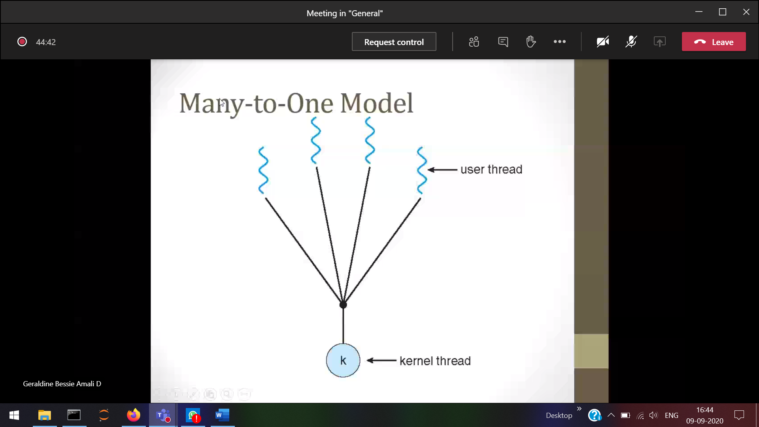

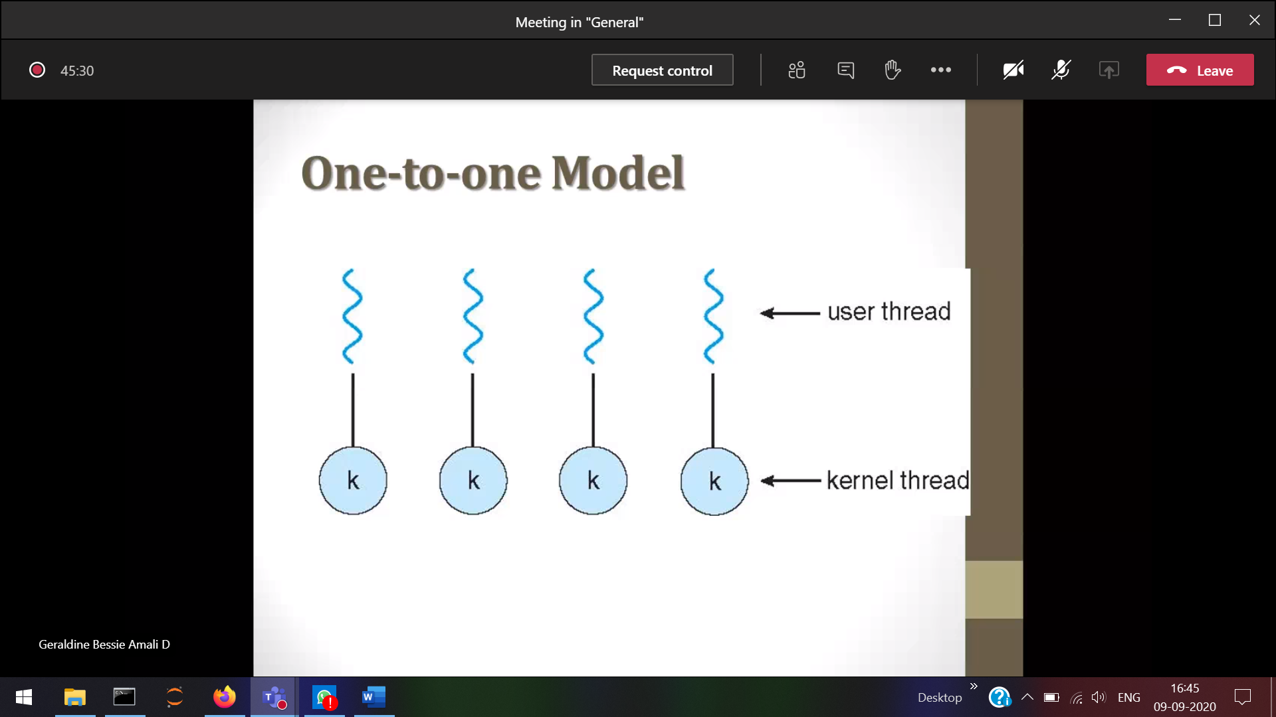

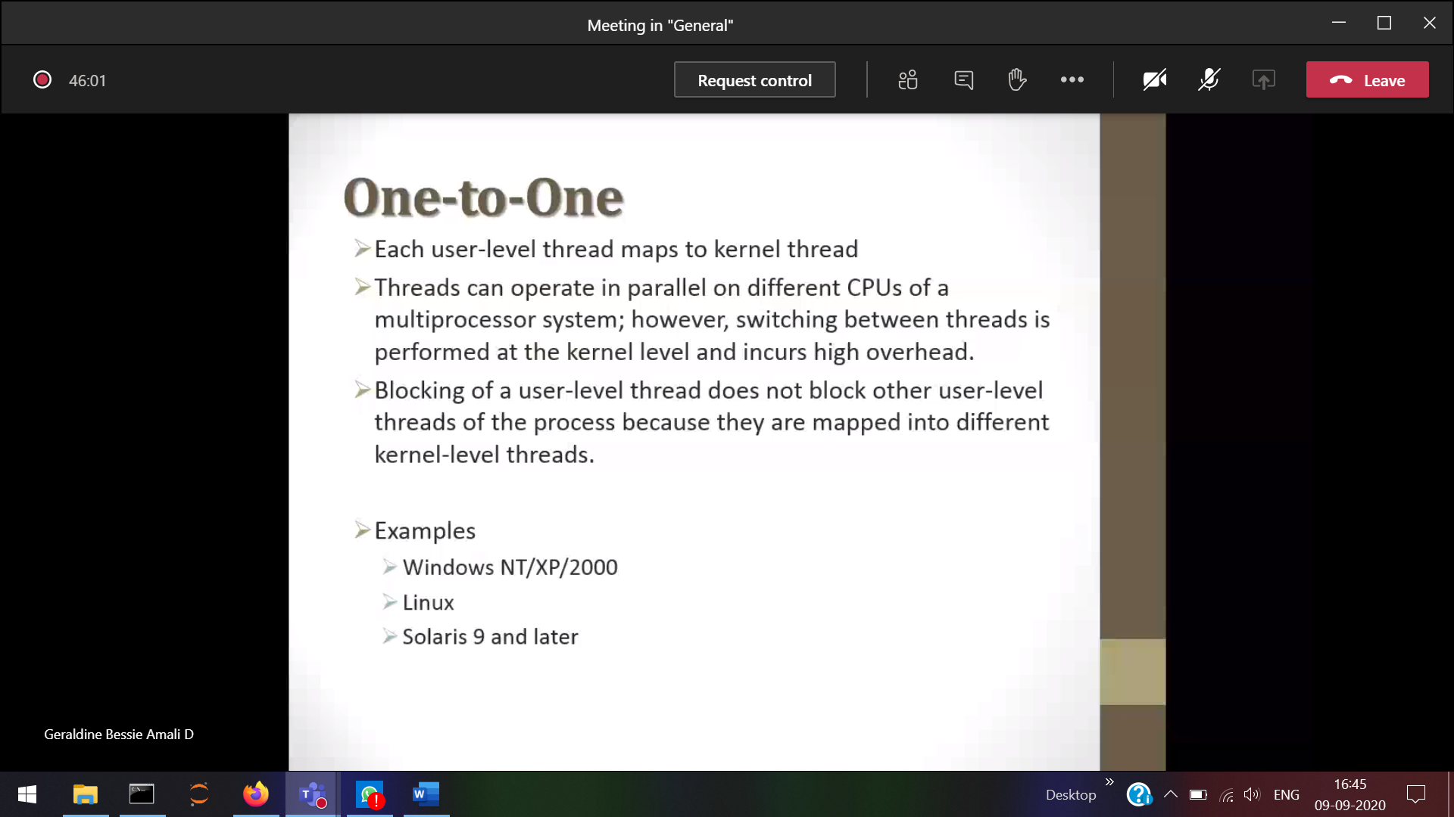

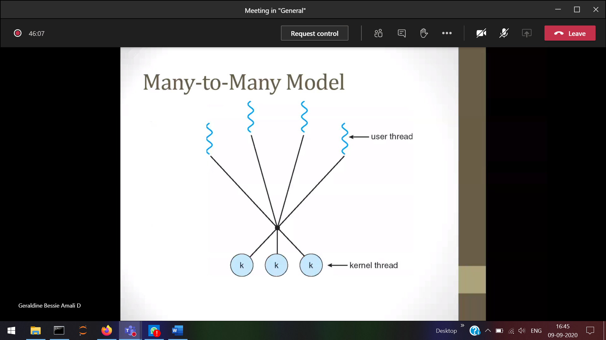

1 blocking in the user 🡪 does not affect another threads